VISTA

VAPALS-ELCAP

Version 18.0

User Manual

May 2019





©Copyright 2019 by Early Diagnosis and Treatment Research Foundation, Vista Expertise

Network, and Paraxial.

This manual is licensed under a Creative Commons Attribution-ShareAlike 4.0 International

license. Visit creativecommons.org for details.

Revision History

|  |  |  |  |
| --- | --- | --- | --- |
| **Date** | **Description** | **Language** | **Authors** |
| May 2019 | Version 18 Release | English (US) | Angel Williams  Kathy Ice |



VA-PALS Mission: To increase access to safe and effective lung screening programs that save lives

Vista Expertise Network Mission: To improve people’s health by changing the way medical software is developed, distributed, and supported

Contents

Orientation 1

The VAPALS-ELCAP Nurse Navigator/Coordinator 2

Justification 2

Functional Statement 3

VA-PALS Participating Sites 6

Introduction 8

Using the Forms 8

Submitting and Saving 8

Launching VAPALS-ELCAP 8

The Home Page and Case Review Page 8

Deleting a Form 9

VAPALS-ELCAP Forms 10

Lung Screening and Surveillance Intake Form 10

Encounter Note 13

Background Form 14

Followup Form 16

CT Evaluation Form 18

PET Evaluation Form 20

Intervention and Surgical Treatment Form 23

Biopsy Form 26

Elcap Screening Protocol 27

Overview 27

Indications for screening 27

Frequency of screening 27

Communication of results 27

Regimen of screening 28

Smoking cessation 28

Image production 28

Reading of images 29

Definitions of nodules 29

Definitions of nodule consistency 29

Definition of nodule size 30

Probability of lung cancer by nodule size and consistency 30

Assessment of growth 32

Baseline screening 35

Repeat screening 36

Other findings to be documented on the low-dose CT scan 36

Biopsy 39

Classification and characterization of diagnosed cancers 39

Intervention policy 40

Outcome determination 41

The I-ELCAP Management System 41

Quality assurance 42

References 43

Appendix A: CPT Codes 51

Please Note: 51

External Links: 52

CT ORDER 52

Appendix B: Sample Patient Letter 53

Veteran Affairs Medical Center 53

Appendix C: Decision-Making Guide 54

Appendix D: Shared Decision Making Verification Form 58

# Orientation

This manual is a guide for scheduling, performing and tracking lung cancer screenings using the VAPALS-ELCAP Management System based on protocols developed by the IELCAP (International Early Lung Cancer Action Program) team. This manual includes forms used by the Nurse Navigators/Coordinators to keep track of patients enrolled in the Lung Screening Program and is therefore oriented around the various forms.

The VAPALS-ELCAP software is web-based, and designed to scale with your browser window, regardless of the size of window you prefer. For this manual, we have used screen shots with a rather narrow browser window, simply because they would fit more easily on the page. Your browser window may look a little different, but the basic information and instructions for use should not change.

The manual is organized so that samples and blanks of the various forms come first, followed by a general discussion of the ELCAP screening protocol. Note that online help is available for the forms when you are using them in the VAPALS-ELCAP software.

All patient information depicted in the screen shots is from synthetic patients generated by Synthea™, an open-source synthetic patient generator.

# The VAPALS-ELCAP Nurse Navigator/Coordinator

## Justification

This position makes the first impression on the patient and is the face of VA lung screening. The Lung Screening Nurse Navigator/Coordinator is critical to the success of the lung screening effort for veterans. The responsibilities include the initial contact with veterans; coordinating and scheduling lung screenings; collecting, inputting, and managing veteran information; compiling and reporting program progress and challenges faced as well as offering recommendations for improvement. This person will report to the site program leader and contribute in a team effort to participate in national VA lung screening conferences and site visit meetings in order to make the national and local VA-PALS lung screening programs as effective and efficient as possible.

### Sample Functional Statement

1. **ADMINISTRATIVE QUALIFICATION STANDARDS**

|  |  |  |  |  |
| --- | --- | --- | --- | --- |
| **Citizenship** | **RN Licensure** | **EDUCATION** | **RN EXPERIENCE** | **Other** |
| United States | Current, full, active, and unrestricted in any US state, Commonwealth, Territory, or the District of Columbia | Bachelor of Science in Nursing (BSN) | 2 to 3 years | (Upon Appointment only)   1. Satisfactory physical examination as determined by the Employee Health Unit 2. Verbal and written English language proficiency |
| Associate Degree in Nursing or Diploma in Nursing and a bachelor’s degree in a field  related to nursing | 2 to 3 years |
| Master of Science in Nursing (MSN) or Master’s in a field related to nursing with BSN or  bachelor’s in a field related to nursing | 1 to 2 years |
| Master of Science in Nursing (MSN) from Bridge Program (a BSN is not issued or  required) | 1 to 2 years |
| Doctoral degree in nursing or related field | None |

All schools of nursing must be accredited by the appropriate State agency, and accredited by either Accreditation Commission for Education in Nursing (ACEN) or the Commission on Collegiate Nursing Education (CCNE) at the time the program was completed.

1. **GENERAL DESCRIPTION OF ASSIGNED DUTIES**

**Scope of Lung Cancer Screening (LCS) Nurse Navigator/Coordinator:**

The LCS Nurse Navigator/Coordinator will organize and coordinate the implementation and day-to- day operation of Lung Cancer Screening at [inset facility name]. The LCS Nurse Navigator/Coordinator serves as an essential link between patients and other specialty services and functions as a patient advocate to help patients along the health care continuum.

The LCS Nurse Navigator/Coordinator will work under the direction of the [insert facility name] program leader, with the guidance of <service line or ELCAP>, to organize the launch of lung cancer screening, outreach, coordinate day-to-day program activities. The LCS Nurse Navigator/Coordinator collaborates with medical media and outreach departments and other tools to educate referring physicians to help close patient care gaps. The LCS Nurse Navigator/Coordinator develops and provides education about the program to providers and patients, tracks and coordinates ongoing patient care, ensures continuing quality and safety initiatives, and collects and reports program evaluation data as requested by leadership.

The LCS Nurse Navigator/Coordinator will serve as an operational resource for the local program members, which may include clinical staff from primary care, mental health, pulmonary medicine, cardiothoracic surgery, pathology, medical oncology and radiation oncology (using ELCAP protocol). The LCS Nurse Navigator/Coordinator is encouraged to participate in local Motivational Interviewing training (VA TMS online course – to enhance the patient education skill of the clinician) as well as TEACH for success (VA TMS online course- Health promotion/disease prevention program).

The LCS Nurse Navigator/Coordinator supports the project mission through collaboration with investigators and protocol personnel. In the performance of these assigned duties, the Nurse Navigator/Coordinator will assure adherence to facility protocols, procedures and program plans established for lung cancer screening.

1. **ROLES**
   1. **Recruitment**
      1. Performs activities related to the lung screening program including but not limited to: initiating phone calls, screening veterans for eligibility, registering veterans, and administering lifestyle questionnaires.
      2. Prescreens patients for appropriateness of lung cancer screening, and discusses rationale and options with patients. Obtains comprehensive health complete histories, and performs complete physical exams during initial evaluation as well as subsequent follow up. Documents in medical record.
   2. **Data Management**
2. Responsible for following study protocols and documentation of study data points; lead the collection and submission of project data from a variety of sources.
3. Completes clinical documentation in the electronic medical record, as needed.
4. Applies specialized expertise to assess, design, and evaluate clinical and administrative information technology solutions.
5. Leads the collection and submission of data from a variety of sources (VISTA & VA-ELCAP).
6. Maintains source documents and patients’ files as required by the protocol.
7. Collects and records study data. Inputs all information into database.
   1. **Screening Protocol**
8. Optimizes patient-centered care practices through patient education, care management and appropriate utilization of system processes.
9. Serves as the point of contact for referring physicians and clinical staff to assist in scheduling patients.
10. Facilitates LDCT scheduling and appointments for consults and support services within established service standards as necessary.
11. Collaborates with Radiology to facilitate the efficient scheduling of imaging examinations.
12. Coordinates with radiologists to ensure scans are read in a timely fashion.
    1. **Follow-Up and Reminders**
13. Identifies health care needs and assesses health status of patient /family during outpatient encounters, including initial evaluation and subsequent outpatient care follow-up, as well as inpatient hospitalization if appropriate. Monitors patients across the health care continuum and develops strategies to maximize compliance with recommended interventions.
14. Identifies and collaborates with the specialty interdisciplinary team in the design of patient treatment plans.
15. Enters diagnostic imaging and laboratory orders, orders appropriate tests and therapy, discusses appropriate plan and interventions with the physicians.
16. Monitors patients due for screening and assists with scheduling screening scans and follow- up procedures.
17. Maintains surveillance tracking database.
    1. **Reporting**
18. Ensures timely follow-up of abnormal findings including referral of any incidental findings.
19. Submits the volume of rural patients, patient scans, and missed patients.
    1. **Veteran Education**
20. Collaborates in the development of patient educational programs and tools for Lung Cancer Screening.
21. Maintains abreast of developments in the conduct of Lung Cancer Screening by attending professional conferences, meetings and training courses. Discusses the program and screening harms and benefits with patients (if part of local process).
22. Facilitates follow-up referrals to evidence-based smoking cessation care.
    1. **Outreach**
       1. Facilitates community outreach as per institutional protocol.
       2. Organizes and leads in-services to educate and share information about the LCS Program with clinical staff.
       3. Utilizes essential customer service skills in meeting the needs of patients, their representative, and all VA staff, consistently communicating in a courteous, tactful and respectful manner.
       4. Provides patients with consistent information per established policies and procedures.

**ACCOUNTABLE TO: Program Leader**

# Introduction

The VAPALS-ELCAP software is the product of a partnership between the VA’s Partnership to Increase Access to Lung Screening (VAPALS) and the Early Lung Cancer Action Program (ELCAP). The ELCAP team has spent the past 17 years perfecting a series of protocols for the early detection of lung cancer. For that reason, the VAPALS-ELCAP team is calling this Version 18, although it is the first version developed for Vista. It is an acknowledgement of all the work that has come before.

For this first phase of the project, the VAPALS-ELCAP team has taken the proven methodologies developed by the IELCAP team, translated them into Vista, and made workflow modifications based on feedback from VA clinicians. The goal for this first phase was simply to adapt the IELCAP forms to VA clinical procedures. It is important to note that although the VAPALS-ELCAP software runs within Vista and uses Vista standards and conventions, it is not completely integrated with Vista's database.

Patient information can be pulled into the VAPALS-ELCAP application in order to pre-populate the forms. However, this information “lives” in Vista and cannot be changed from VAPALS-ELCAP. If, for example, a patient tells you they have a new address, you will need to make the correction in Vista.

## Using the Forms

As you fill out the VAPALS-ELCAP forms, the system automatically checks and validates the values that you put in.



If your value passes the validation test, you'll see a green checkmark, as shown above.



If your value is invalid, you'll see a red x, as shown above. You may also see a red x in required fields that have been left blank.

### Submitting and Saving

Most forms have two buttons at the bottom: one for submitting the form, and one that says “save for later.” If you use the “submit” button, VAPALS-ELCAP will look at all your answers and make sure all of the required fields are filled out with valid information. If there are any issues with the way the form is filled out, VAPALS-ELCAP will not accept it and will send you back to correct the errors.

If you use the “save for later” button, VAPALS-ELCAP does not perform the validation checks because it knows you're not done yet. You can continue to update and change the form until it is signed.

## Launching VAPALS-ELCAP

VAPALS-ELCAP is launched from CPRS. To access it, log into CPRS and go to the Tools menu. You should see VAPALS-ELCAP as one of the options. If you do not, or if it does not work properly, please consult your supervisor or IT department.

## The Home Page and Case Review Page

When you first sign in to the VAPALS-ELCAP software, you are directed to the home page. Here you can look up your patient, using either the patient's name or “last5;” that is, the first letter of the patient's last name and the last 4 digits of their Social Security number. If you had already selected a patient in CPRS, that patient will automatically be pulled up in VAPALS-ELCAP.

If you choose to look up a patient by name, you will see a list of patients you could select as you type. Patients already in the VAPALS program are shown with a VAPALS icon.

If you use last5 instead, you will not see a list as you type; this is to ensure accuracy in selecting patients. Once you have your patient in the box, click the “submit” button.

If the patient is not already enrolled in VAPALS, you will see a pop-up window asking whether you are sure you want to enroll them—just in case you accidentally grabbed the wrong patient.

Assuming you have the right patient, if the patient is new you will automatically be taken to their intake form (see the next chapter for information on the intake form). For an existing patient, you will be taken to their case review page.

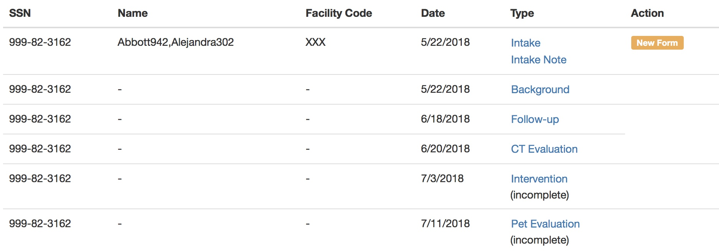

The case review page shows all forms associated with the patient. Forms that have not yet been submitted are listed as Incomplete. (Remember that you can choose to save a form for later; its status will be listed as Incomplete.)

To review or edit a form, click on the name of the form. For example, click on the word “Background” to review or edit the background form. You will only be able to edit a form if its status is listed as incomplete. Generally, once a form has been submitted, it is no longer editable. The exception to this is the intake form, which may be edited to create another intake note. If you need a new form that isn't listed in the patient's case review, click “new form.” You are then directed to another page where you can choose which new form you need for the patient.

Please note that you can only create one copy of a CT evaluation form per patient per day. This is to help prevent additional forms from being created in error.

## Deleting a Form

If you create a new form for the patient in error, you can delete it, as long as its status is Incomplete.

To delete a form, select it from the Case Review page. If the form is incomplete, it will have a Delete button on the bottom left of the form, opposite the Sign and Save buttons.

# VAPALS-ELCAP Forms

## Intake Form

### Chart Eligibility Form

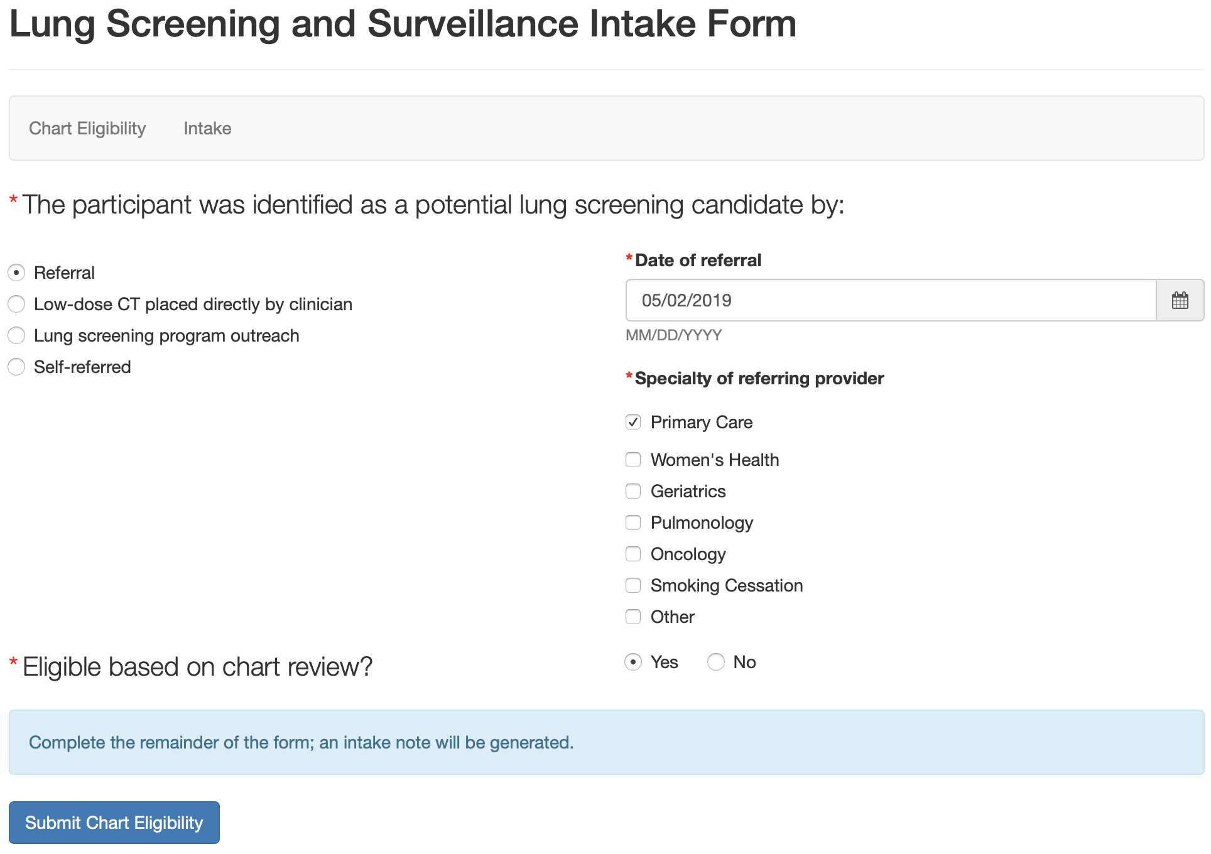

### Chart Eligibility Encounter Note

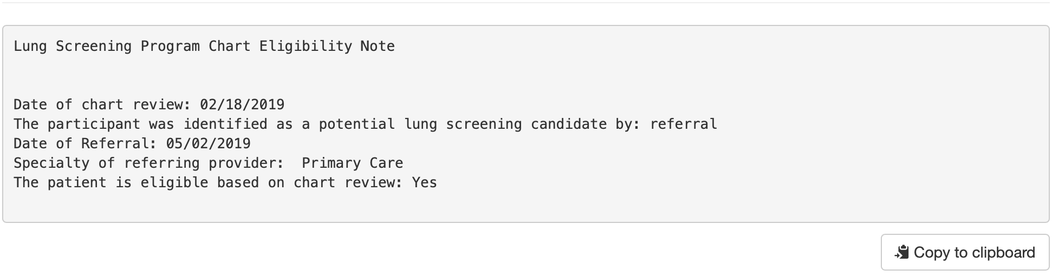

### Pre-Enrollment Form

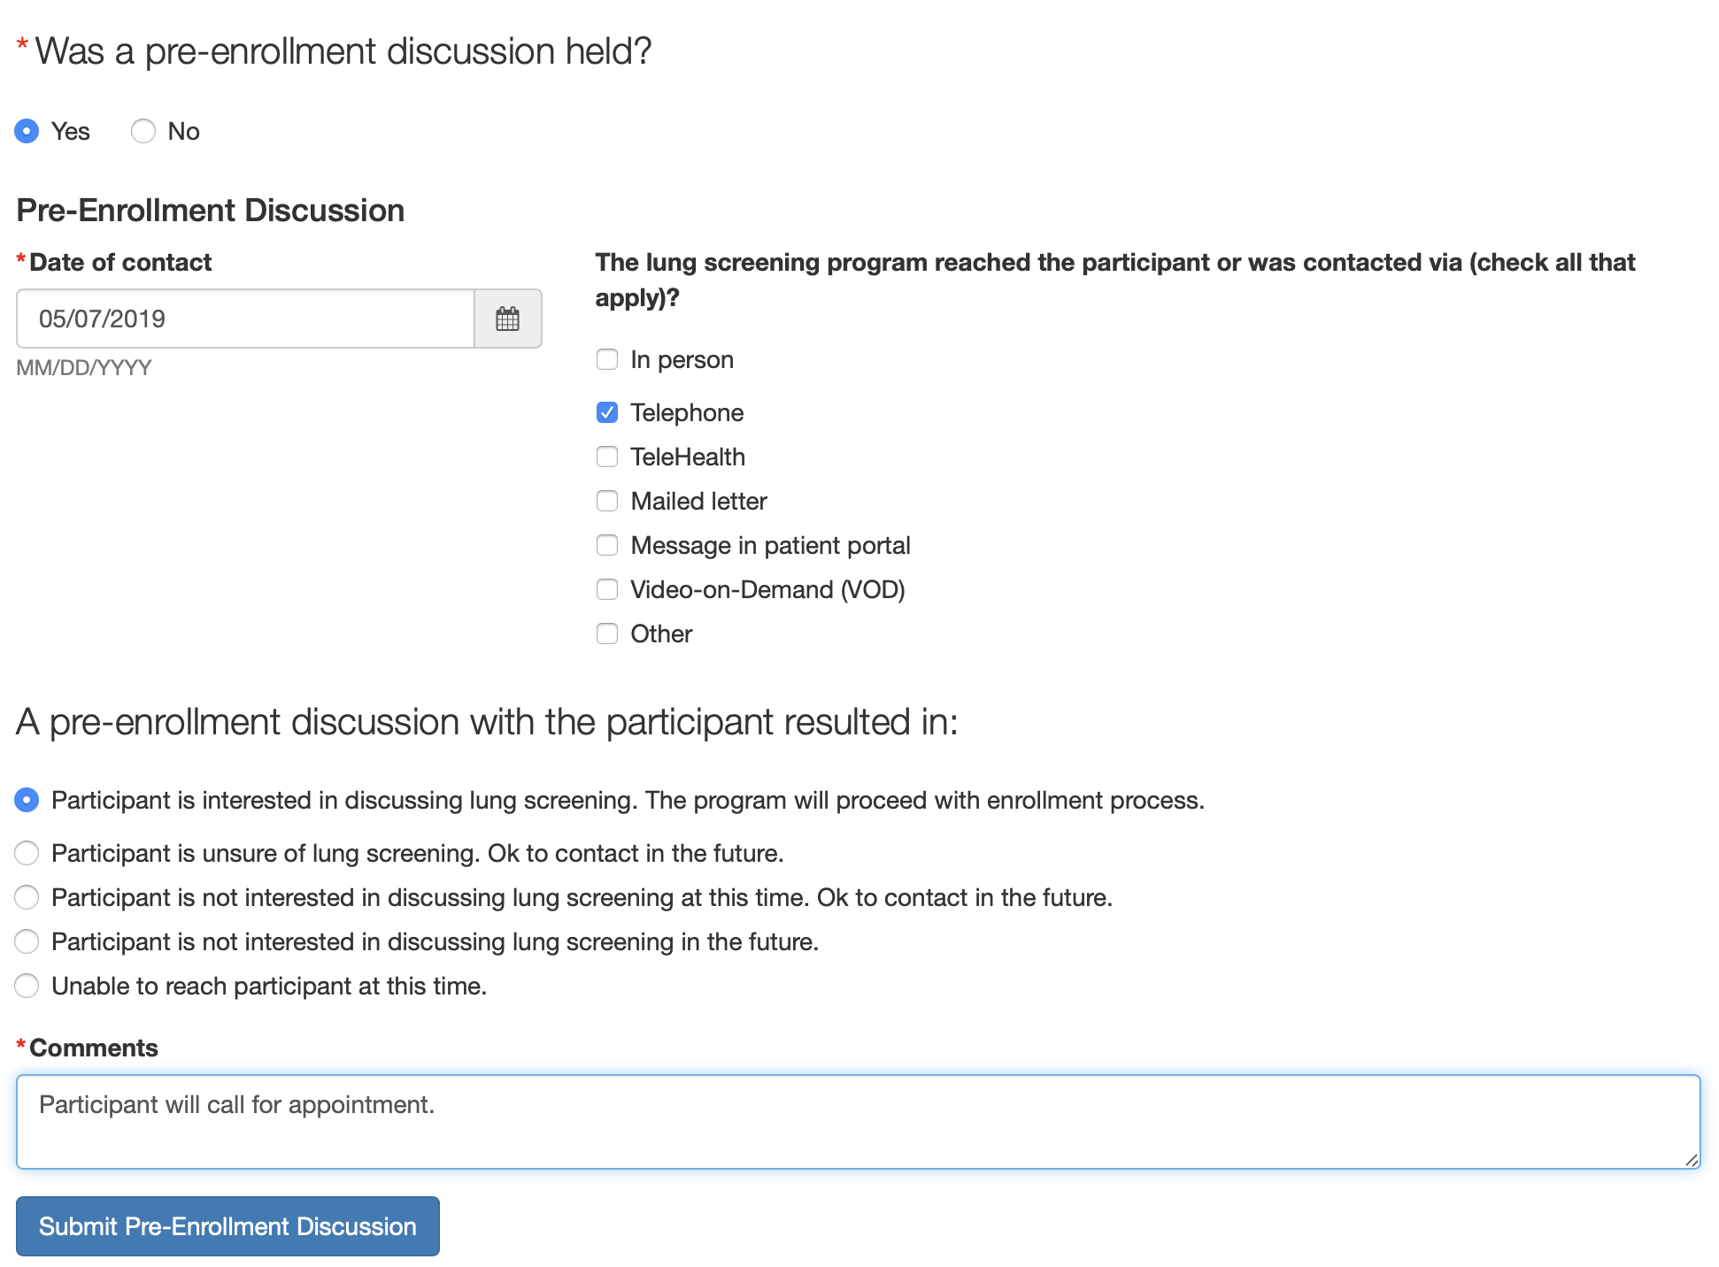

### Pre-Enrollment Encounter Note

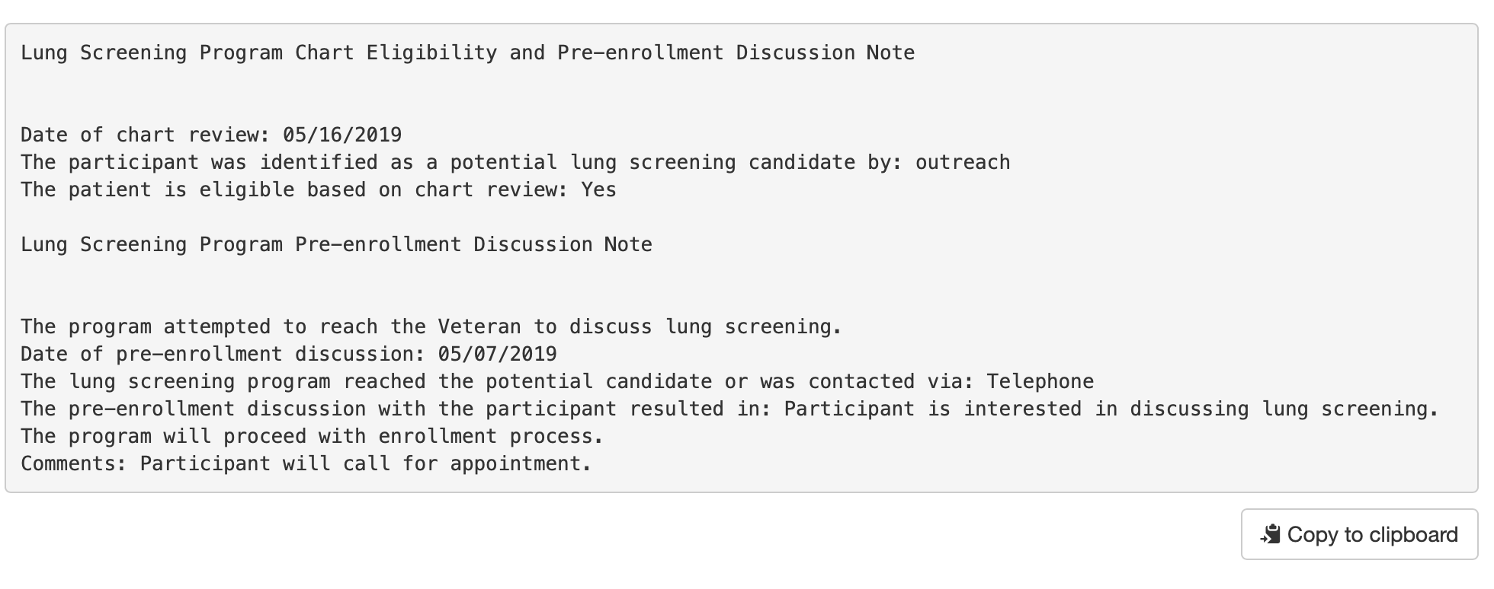

### Main Intake Form

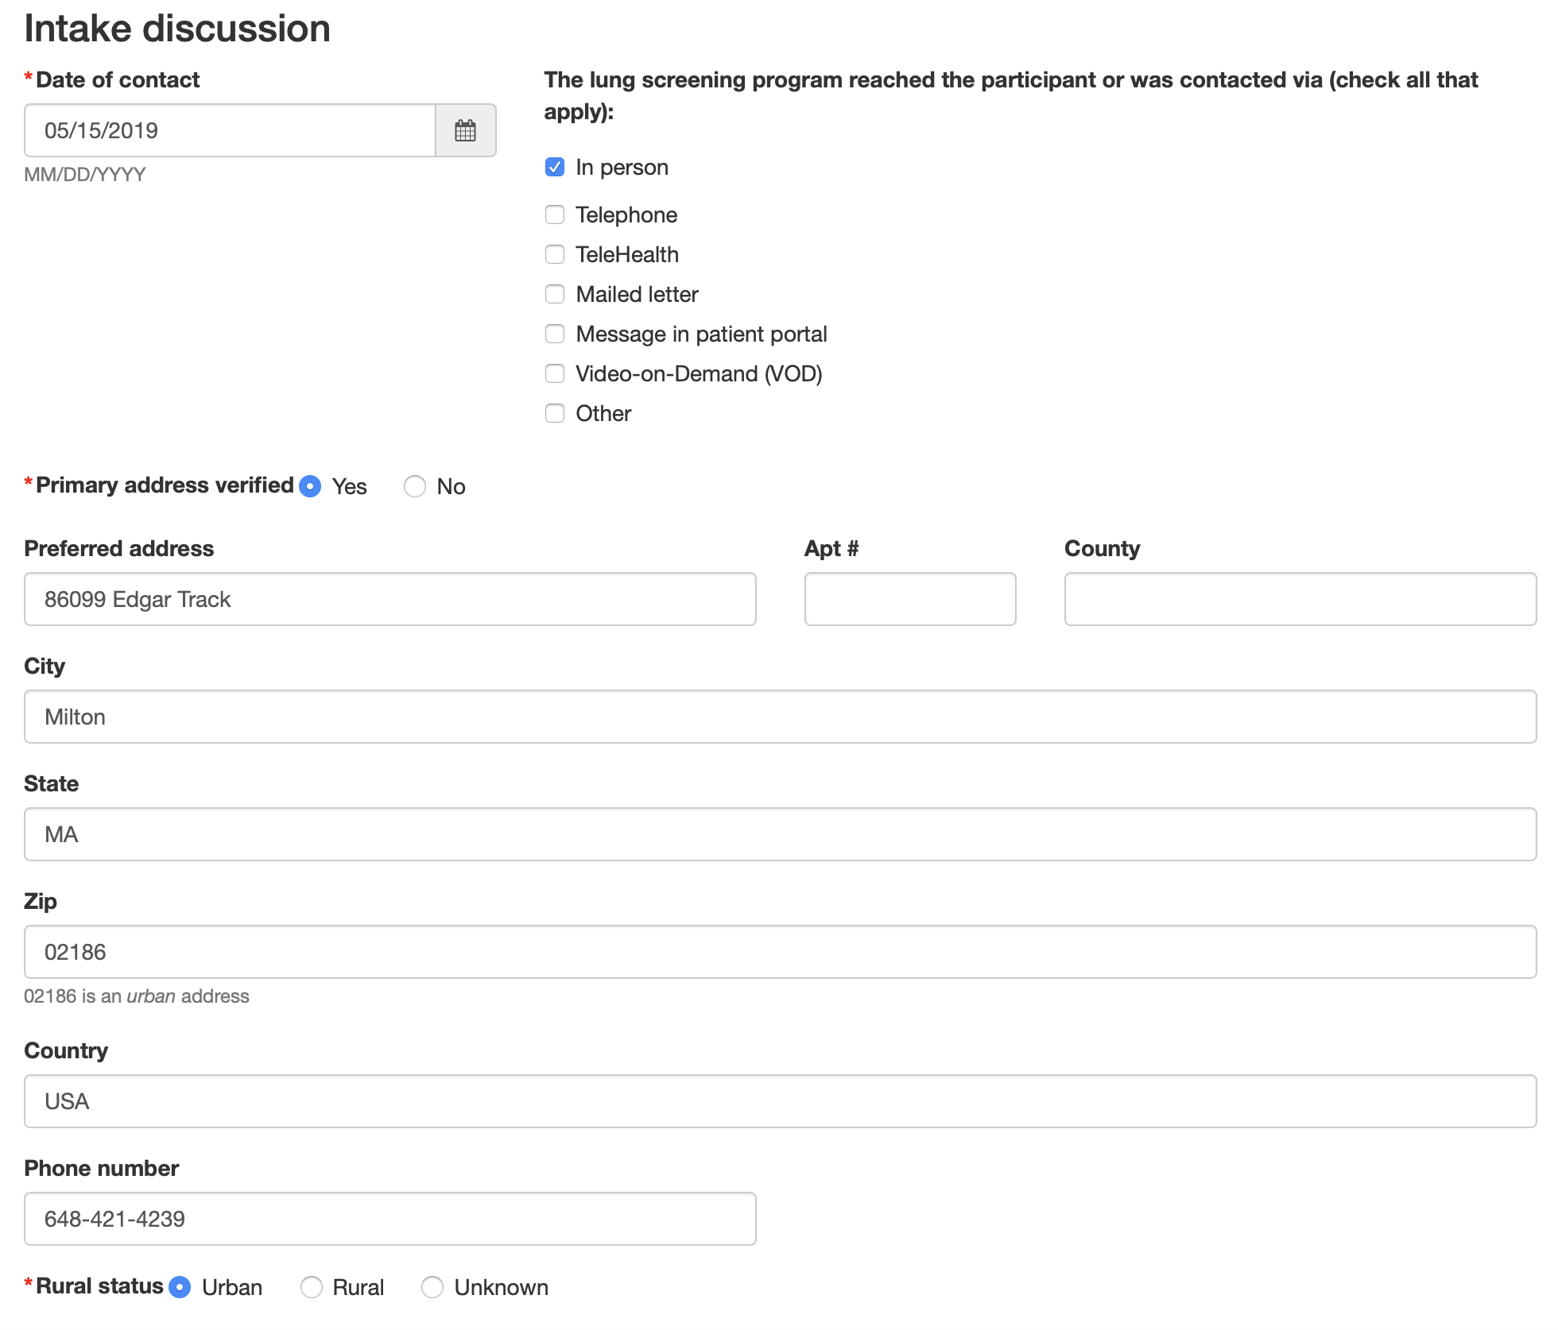

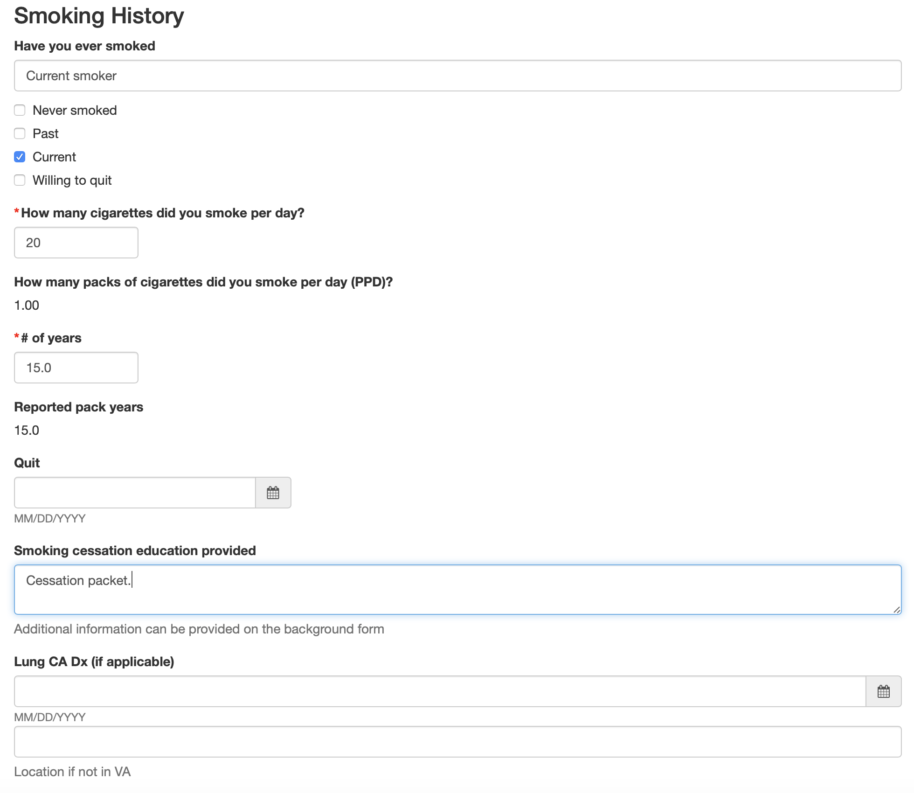

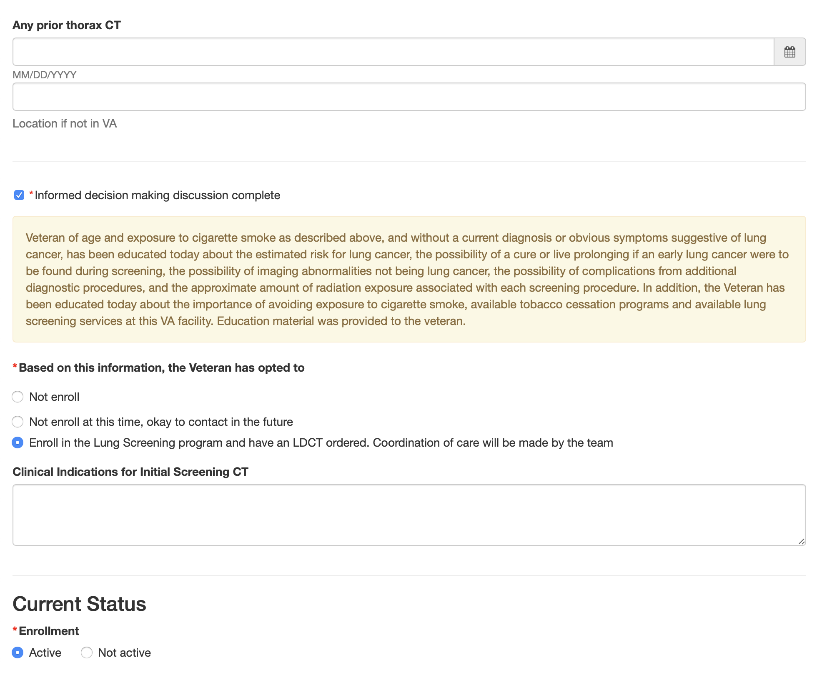

### Main Intake Encounter Note

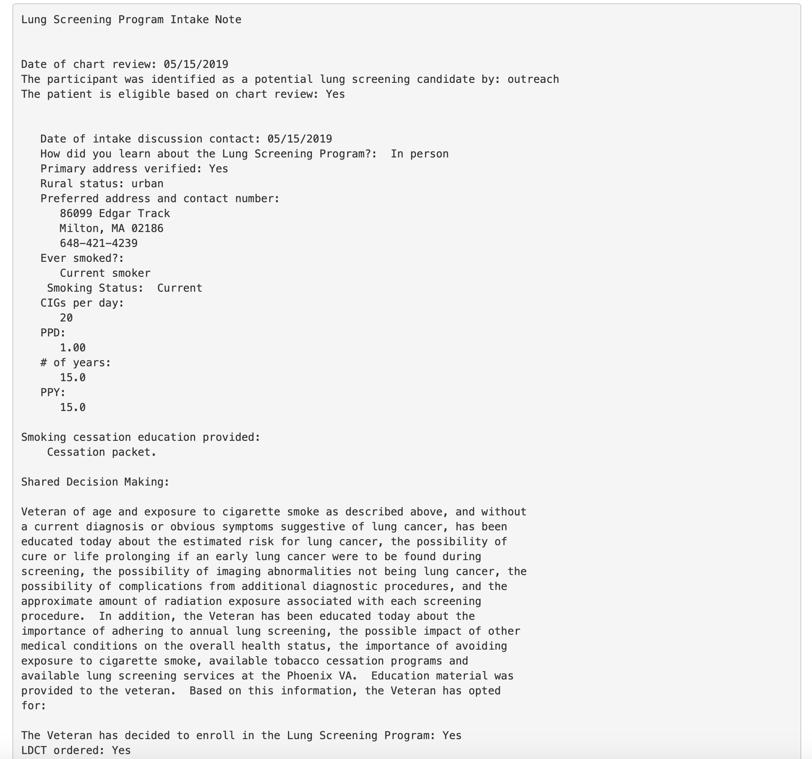

## Background Form

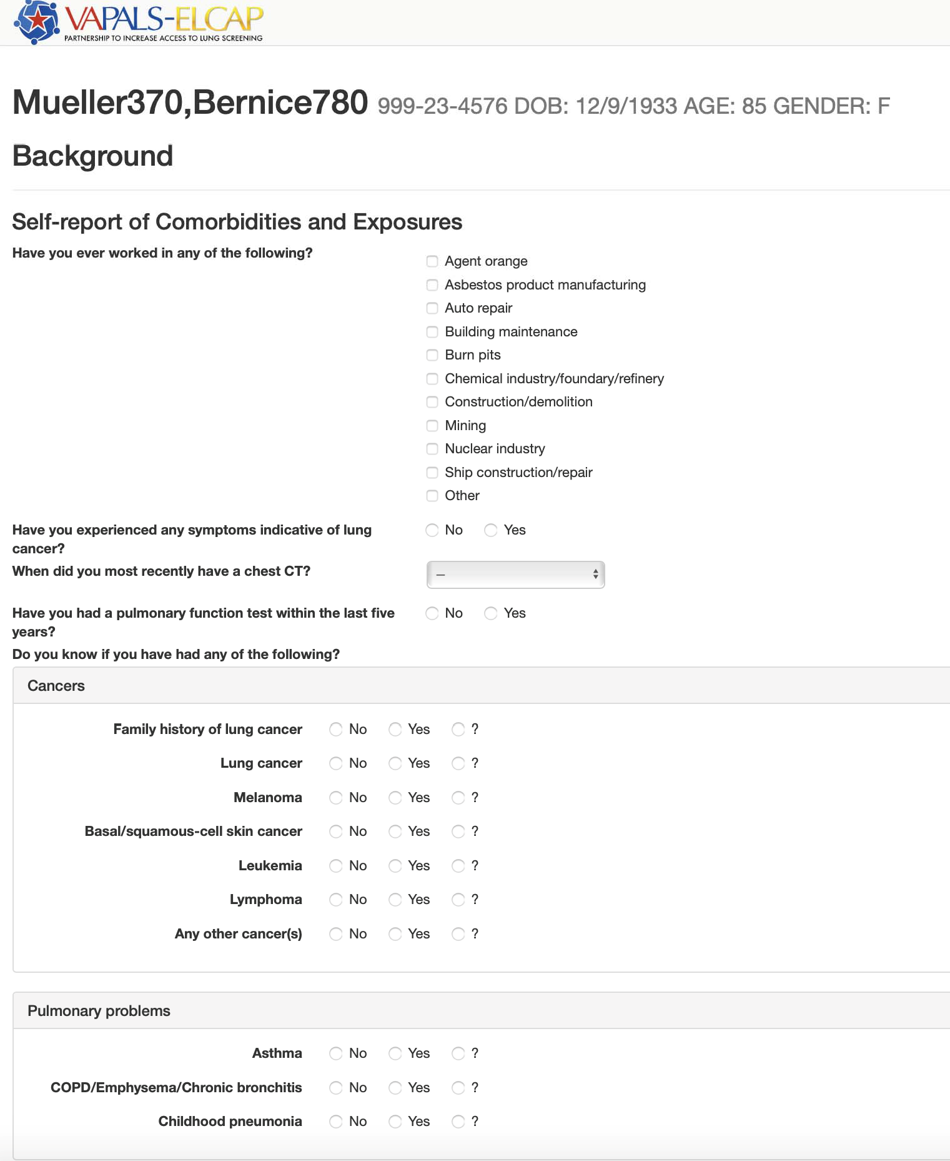

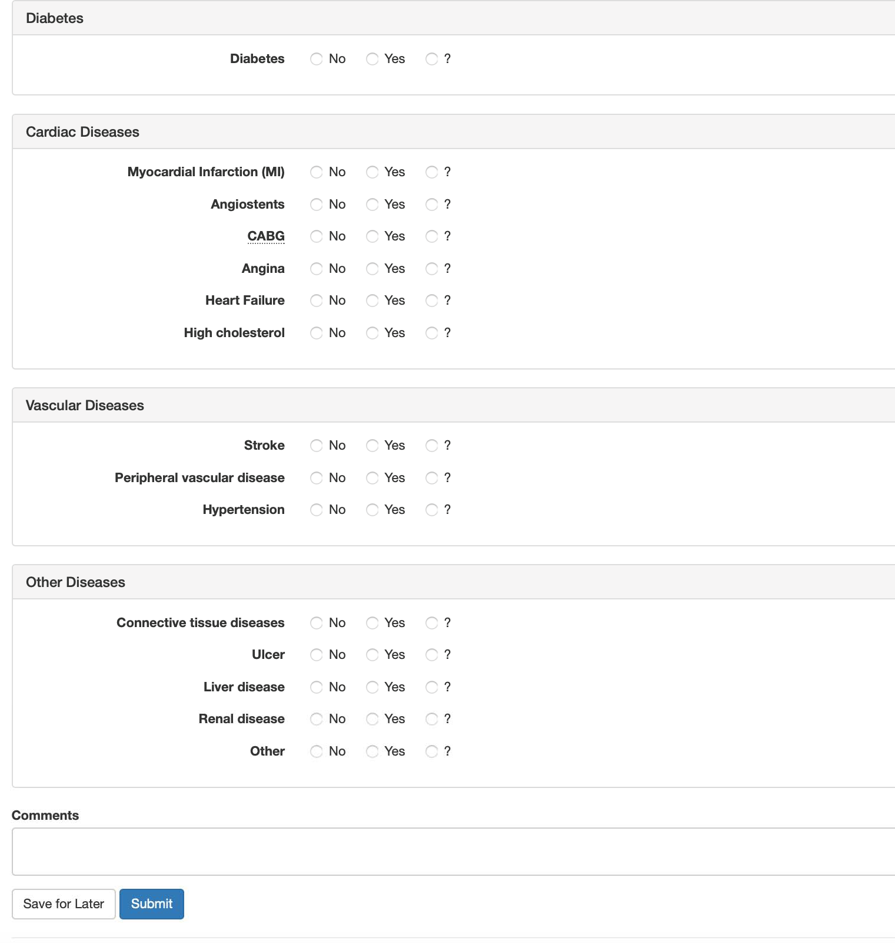

## Followup Form

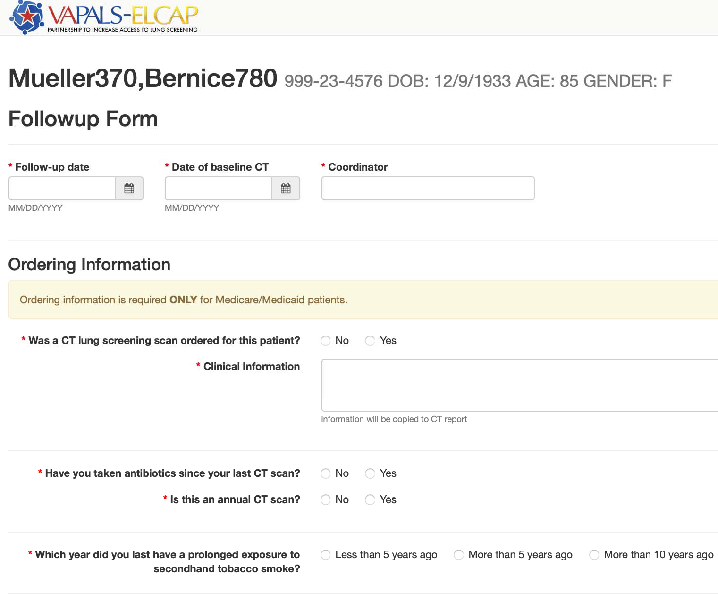

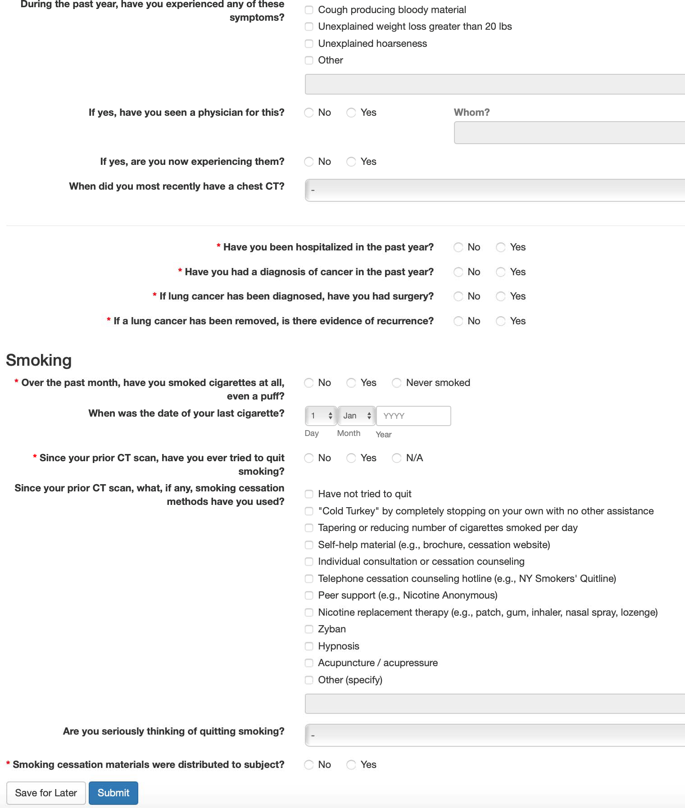

## CT Evaluation Form

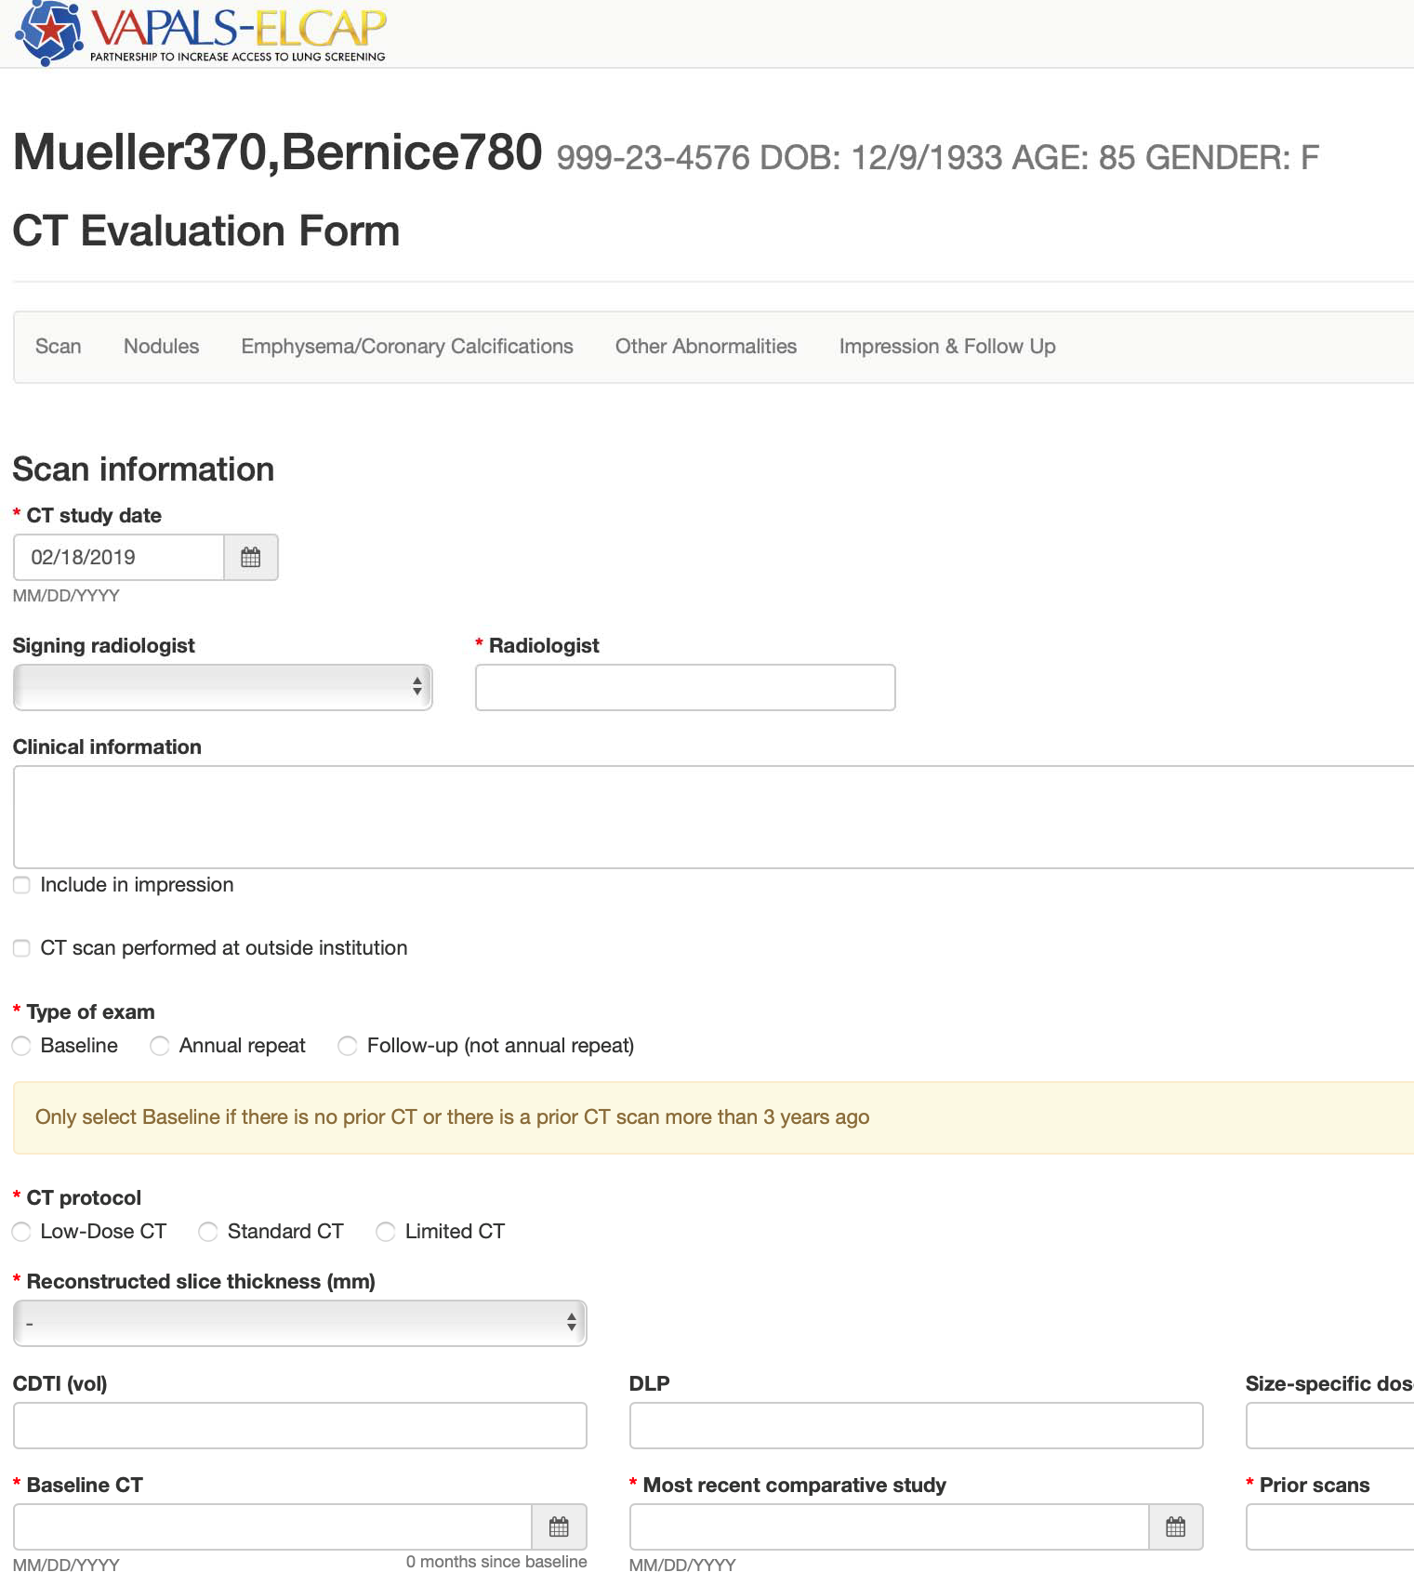

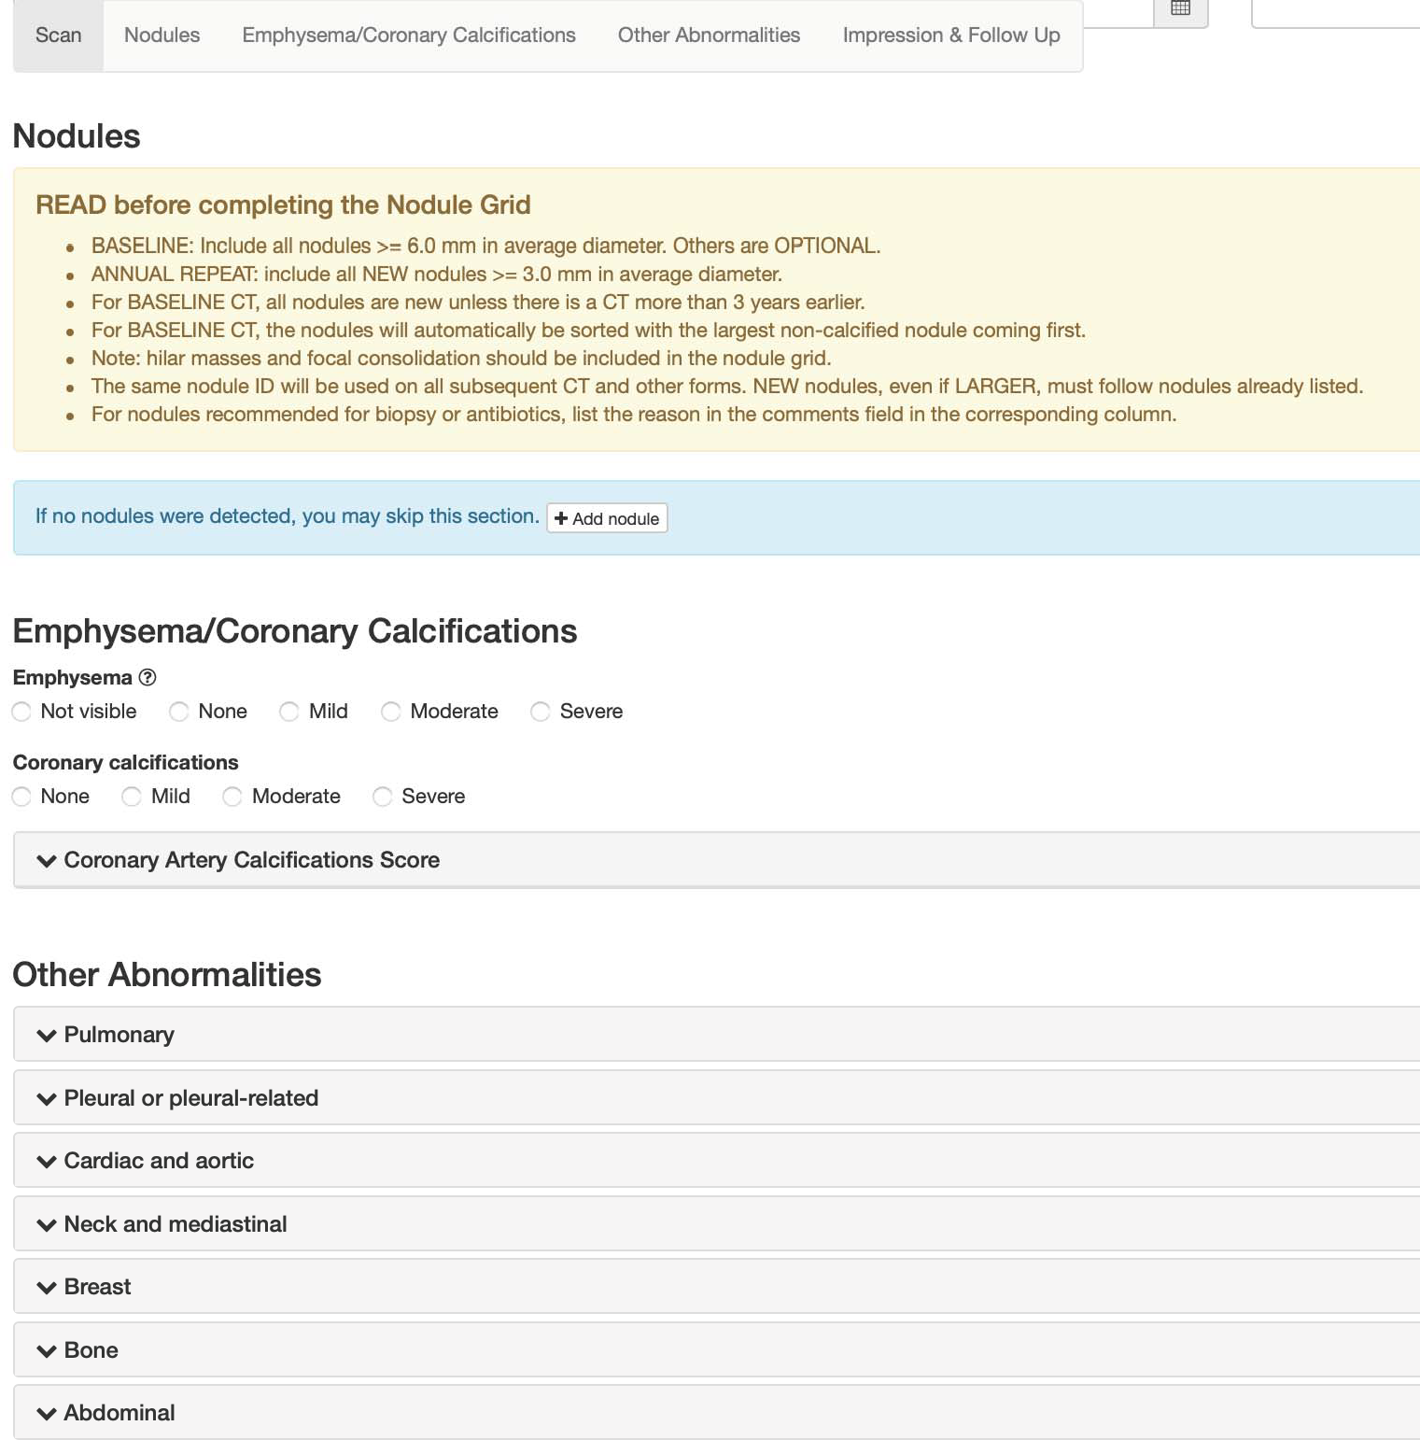

## PET Evaluation Form

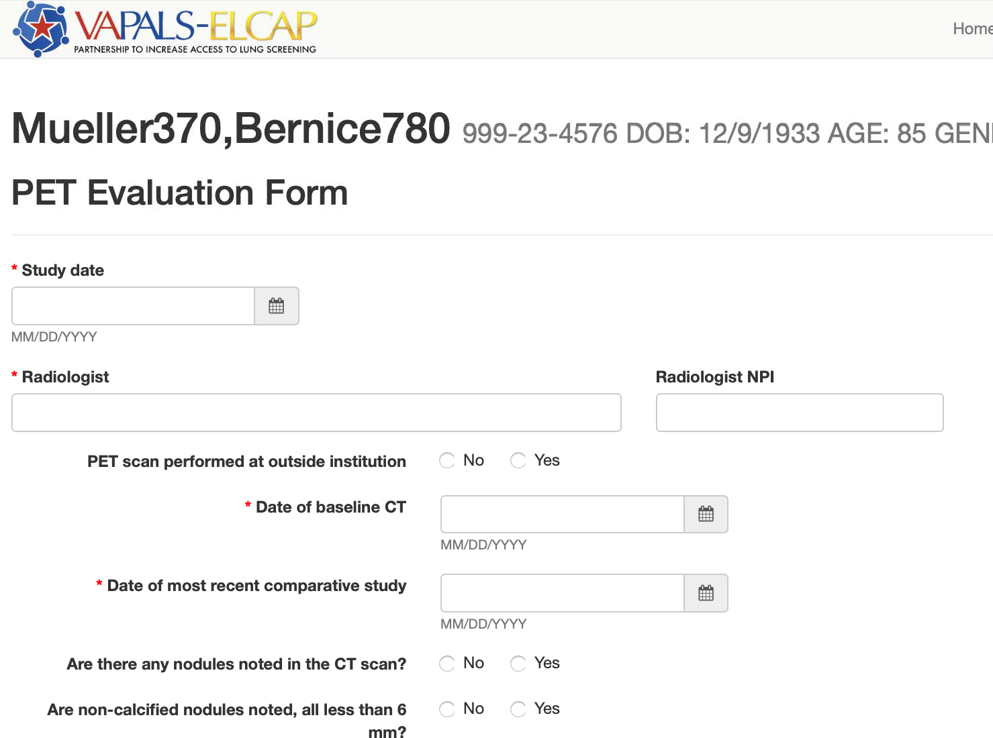

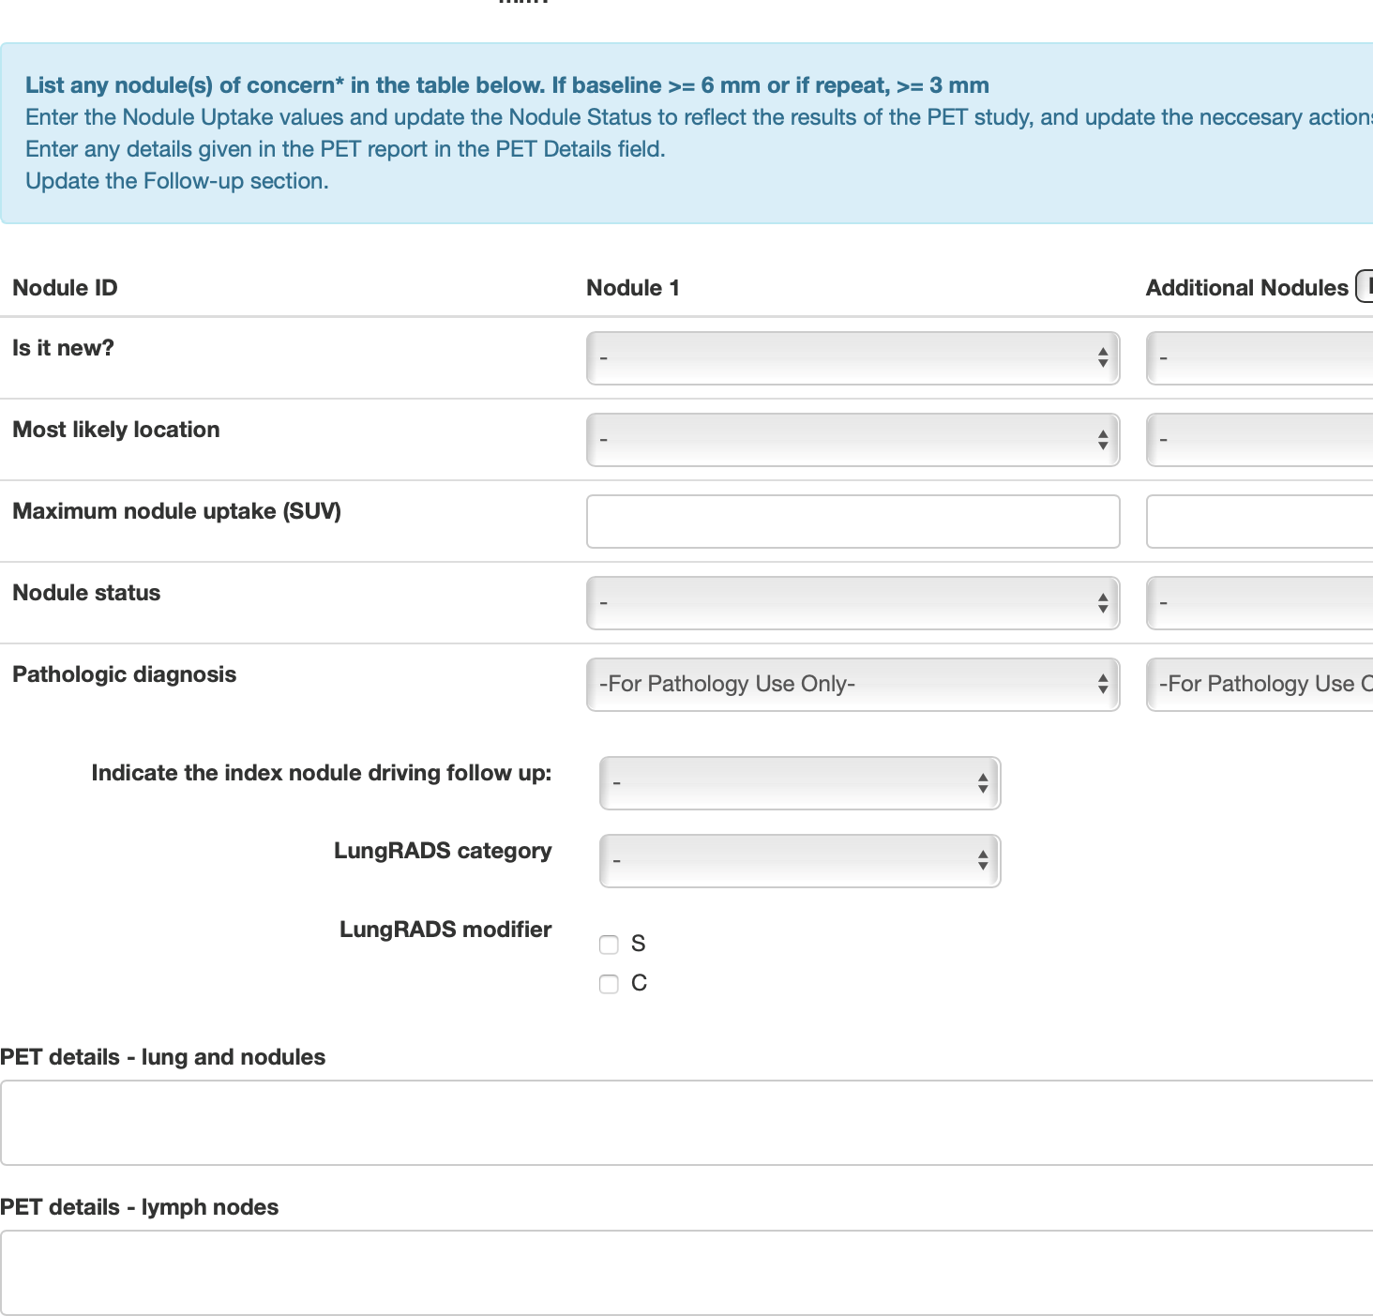

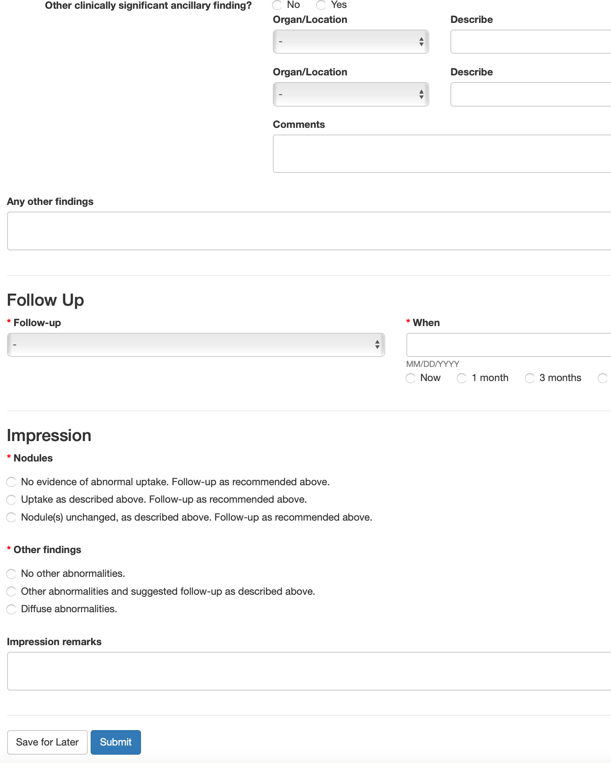

## Intervention and Surgical Treatment Form

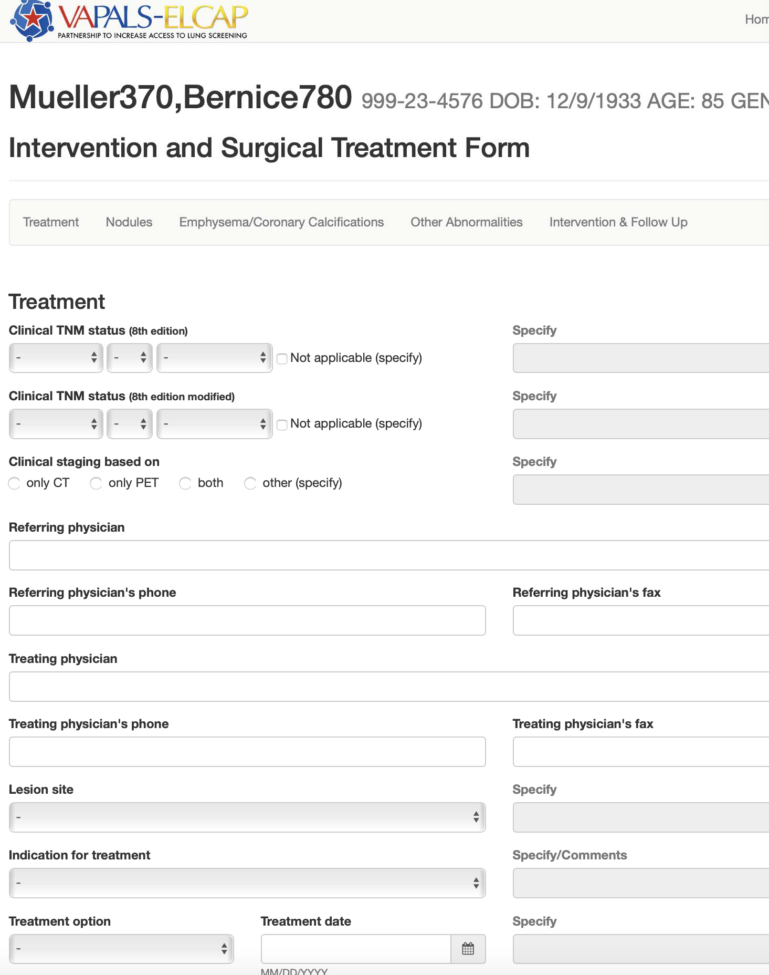

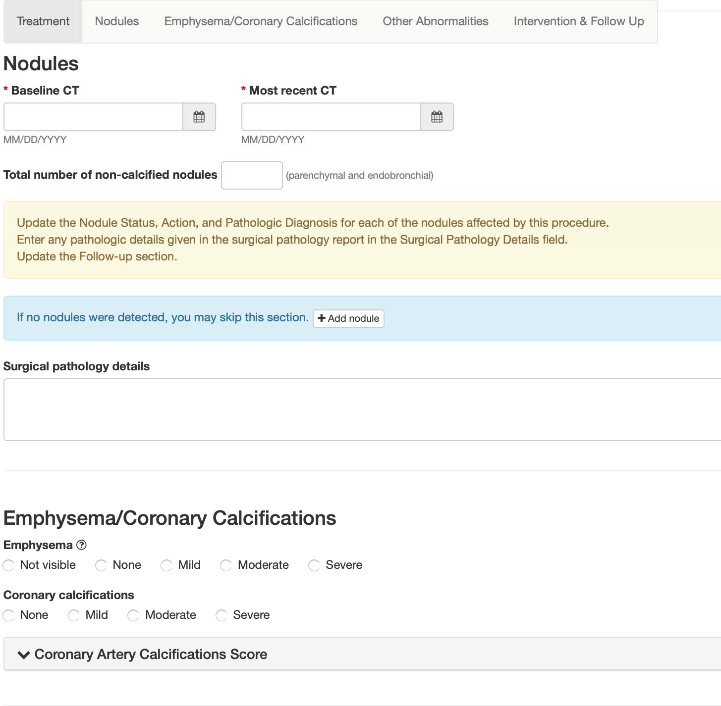

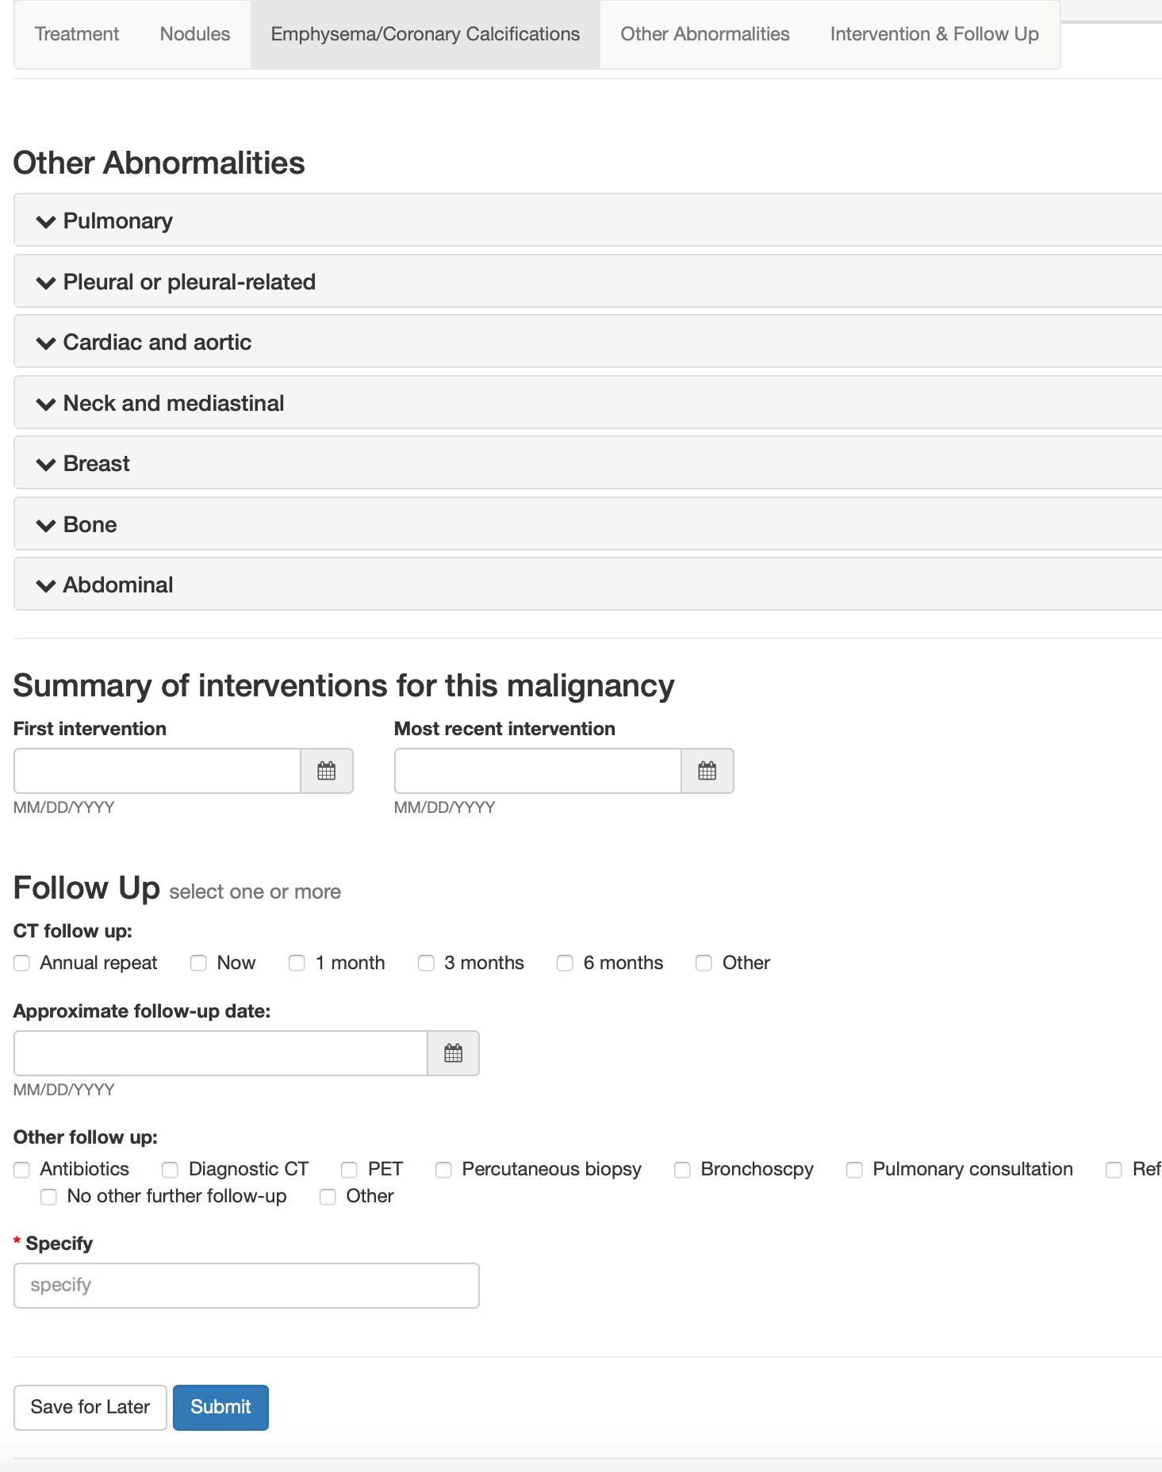

## Biopsy Form

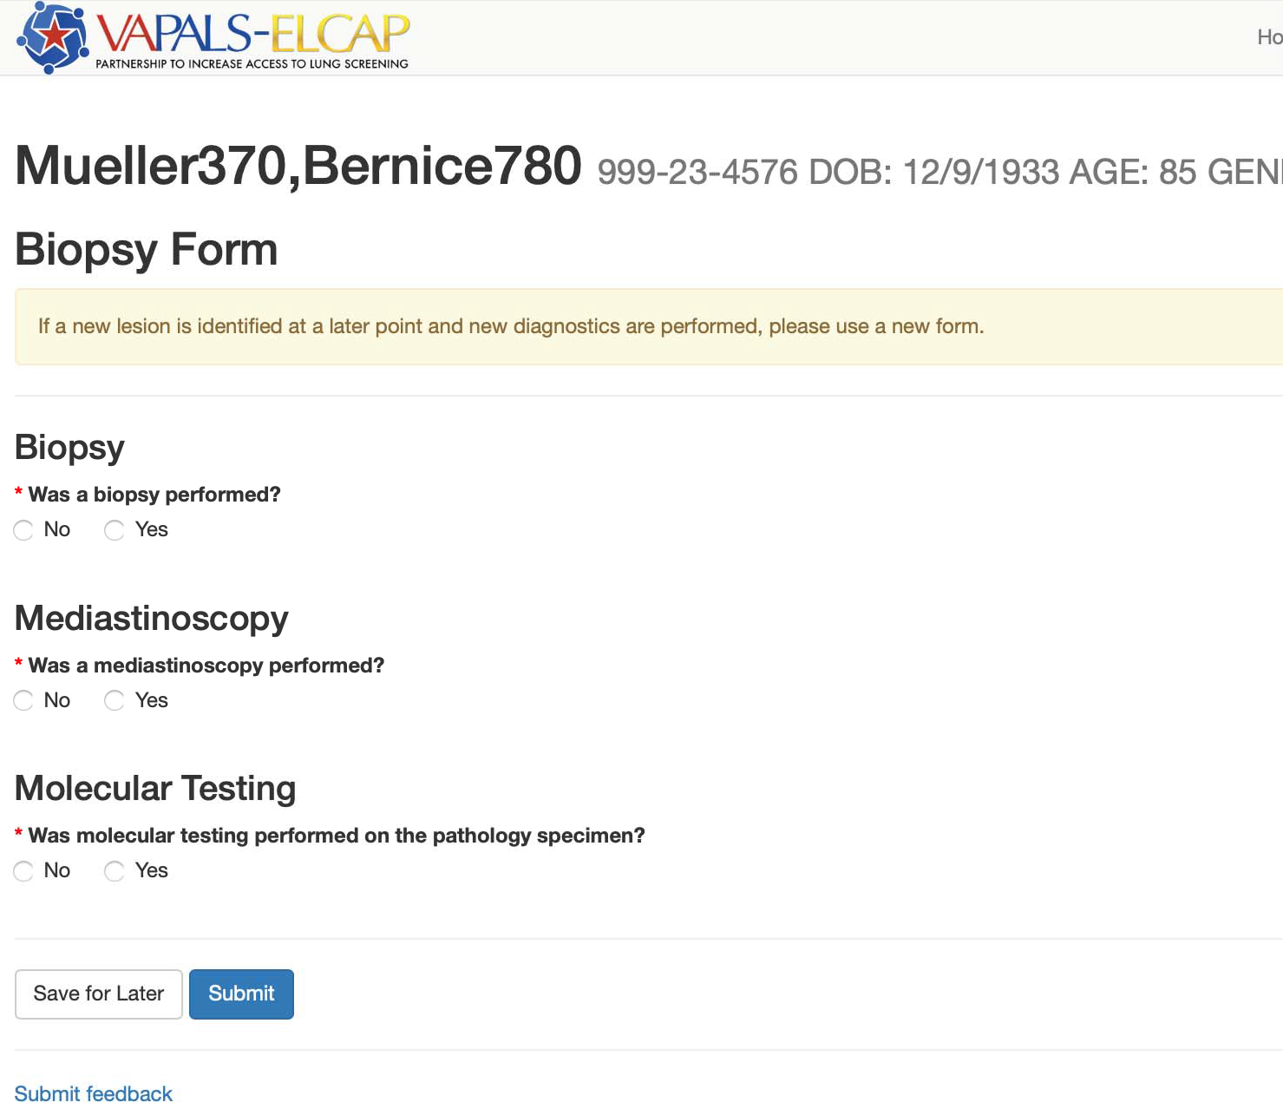

# Elcap Screening Protocol

## Overview

The development and refinement of the International Early Lung Cancer Action Program (I-ELCAP) screening protocol has been a concern of the I-ELCAP (originally the Early Lung Cancer Action Program) team for the past 25 years [1-9]. Its broad research objective has been the advancement of knowledge for early diagnosis and treatment of lung cancer. The protocol has been updated in the framework of the International Conferences [4] organized by this Group. The continued development of the I-ELCAP international consortium on screening for lung cancer has been facilitated by its web-based infrastructure developed in 2001 which has been regularly updated [4, 5]. The research program of I-ELCAP is guided by the common protocol [6, 7], pathology protocol [8, 9], and its approach to long-term follow-up [10-15]. Further details are given in these cited publications.

In the framework of the I-ELCAP protocol, there is opportunity to conduct related studies. Various non-CT approaches to screening, including biomarkers in the broadest sense can be deployed in parallel with the low-dose CT test for their validation, relative merits, and value as add-ons.

## Indications for screening

As screening is for asymptomatic persons, documentation of the symptom profile is needed. Specifically, current presence/absence of potential manifestations of lung cancer which include worsening cough with hoarseness, hemoptysis, and unexplained loss of weight are documented. Symptomatic persons are ineligible for enrollment and should be considered for diagnostic imaging.

Indications for participation may vary among I-ELCAP participating institutions, notably as to age and smoking history, but these must be specified.

If Stage I, II, or IIIA lung cancer has been diagnosed as a result of screening or outside of screening and curative treatment is provided, screening for new primary lung cancers may be provided once treatment is completed.

## Frequency of screening

When application of the regimen of screening at baseline does not lead to the diagnosis of malignancy, repeat screening is scheduled for a preset time from the initial, low-dose test at baseline. Whereas the protocol calls for annual repeat screening, each institution is free to choose the timing of the repeat screening. Such variations do not threaten the validity of the results, so long as they arise from compelling circumstantial matters (and thereby are as though randomly assigned) and these variations also provide an opportunity to study the implications of different intervals to repeat screening in the regimen. The United States Preventive Services Task Force recommends annual screening [16] and the Centers for Medicare and Medicaid Services mandate it [17].

## Communication of results

The results and recommendations of the interpretation of the low-dose CT scan are sent simultaneously to the referring physician and to the participant (with a lay summary) If the participant or his/her physician chooses not to follow the recommended regimen, the actual work-up must be carefully documented using the web-based management system.

## Regimen of screening

In this protocol, ‘screening’ refers to the entire process of the pursuit of early, rule-in diagnosis of lung cancer. It begins with the initial low-dose CT scan at baseline and continues with repeat screenings. A positive result of each screening is followed by follow-up diagnostics which include annual repeat screening, shorter follow-up imaging and, potentially, a biopsy.

It is understood that there may need to be occasional exceptions to the protocol. Each site is fully responsible for performance of the CT scans, their interpretation, and workup recommendations. In those cases for which protocol recommendations are not followed, it is necessary to document the reasons for this and to record all results of the alternative workup. While the regimen has been continuously updated based on the analysis of accrued results of actual screenings and diagnoses of lung cancer, the basic structure of the protocol has remained unchanged.

### Smoking cessation

**Smoking cessation** needs to be incorporated into the program, not only for current smokers but also for former smokers to prevent relapse. CT screening provides “a teachable moment” for smoking cessation advice and has been shown not to cause former smokers to restart smoking. Additionally, personalized counseling or referral to Quit Smoking Help Lines and other support groups is useful. Additional reports on the quit rates in I-ELCAP in the context of screening are provided [18-20].

### Image production

In this regimen, the low-dose CT imaging is the same in baseline and repeat screenings. As there are a large variety of CT manufacturers and models which have markedly improved resolution and other capabilities over time, the following are general guidelines for the image production. Scans should be acquired on multi-detector-row scanners with 16 or more rows. Scans should be acquired so that images can be reconstructed at 1.25mm or less.

**There is no specific definition of “low-dose,”** although historically most screening protocols have used scan parameters of 120-140 kVp and 30-100 mAs. **We suggest that scans be obtained at 120 kVp or lower and 40 mAs (effective) or lower.** An alternative is to use dose-modulation which should be established to correspond to approximately the same dose without modulation.

Collimation and pitch also affect dose, and these should be set to allow for the lowest dose, while maintaining acceptable image quality. Image reconstruction should be performed using a standard, non-edge enhancing kernel to minimize effects of noise. However, additional reconstructions may also be obtained, including maximum intensity projection (MIP) images. Scan parameters should also be adjusted to allow for different size patients. Dose modulation techniques which adjust for body size are available on most modern scanners. These should be established based either on weight or body mass index. In addition, new dose reduction techniques are being made available by scan manufacturers, and their use is encouraged, providing that acceptable image quality is maintained.

Guidance on scan parameters specific to manufacturers make and model can be found on the website of the American Association of Physicists in Medicine ([http://www.aapm.org/pubs/CTProtocols/?tab=5#CTabbedPanels](http://www.aapm.org/pubs/CTProtocols/?tab=5&amp;CTabbedPanels)).

Images should be acquired in a single breath from the lung apices through the lung bases. Standards should be established to ensure consistent breath holding. **Contrast material is not used.**

Just prior to acquiring the low-dose CT scan, the participant is asked to cough vigorously several times to clear the trachea and major bronchi of possible mucus secretions and avoid additionalimaging that might be required to distinguish such secretions from endobronchial lesions.

Follow-up imaging of abnormalities identified as a result of screening should typically be performed using the same low dose parameters used for the baseline and repeat screenings.

### Reading of images

The images are read by a radiologist at the site. The reader is aware from which round of screening (baseline or repeat) that the images derive, as the work-up protocol depends on the round. The reader views the images as they are displayed in a high-resolution monitor at their typical window and level settings -- scrolling through the images one at a time. For the purposes of assessing the size of a nodule or that of a mediastinal abnormality, however, the following settings are used: lung window width 1500 HU and lung window level-650 HU, and mediastinal window width 350 HU and mediastinal window level 25 HU.

In both baseline and repeat screening, the reader’s first concern with the images from the first, low- dose test is to *identify all non-calcified nodules* (NCNs) visible in the images.

For repeat screenings, the reader’s special concerns are to *identify all new NCNs;* and those that produced a semi-positive result on the CT baseline and that showed growth--either in the overall size of a solid nodule, in the solid component of a part-solid nodule, or in the development of a solid component within a previously nonsolid nodule. To determine whether growth has occurred, the reader compares the current images with the corresponding previous ones, displayed side-by-side.

For each of these nodules in the lung parenchyma or bronchi, the reader documents the location, size, consistency (solid, part-solid or nonsolid), calcifications, and nodule edge characteristics (including spiculations). The definitions of nodules, their consistency and size are given below followed by the assessment of nodule growth.

### Definitions of nodules

**A nodule is a focal non-linear opacity with a generally spherical shape surrounded by lung parenchyma.** It is classified as **non-calcified** if it fails to meet the usual criteria for benign, calcified nodules. Thus, a nodule less than 6 mm in diameter is non-calcified if all of it appears less dense than the ribs (on bone and lung windows); a nodule 6-20 mm in diameter is non-calcified if most of it is non-calcified (by that criterion) and/or the calcification does not correspond to a classical benign pattern (complete, central, lamellated, popcorn) and/or the edge is spiculated to any extent; and a nodule over 20 mm in diameter is non-calcified if any part of it is non-calcified judged by the criteria above. Focal pleural thickening or pleural plaques are not considered nodules. **Opacities of 30 mm or more are considered masses.**

### Definitions of nodule consistency

A nodule is classified solid unless it has specific characteristics to be classified as subsolid [21]. Solid nodules may have external or internal cystic airspace or internal cavitation [7, 22]. Subsolid nodules may be either nonsolid or part-solid [23-27]. A part-solid nodule is one that has internal components that completely obscure the lung parenchyma; and considered nonsolid if none of the lung parenchyma is completely obscured.

In making the distinction between part-solid and nonsolid nodule, blood vessels within the nodule, despite their appearance as solid components, are not regarded as solid components. Part-solid nodules are nodules which may start as nonsolid nodules and subsequently develop a solid component within the previously nonsolid nodule.

When determining the distinction between part-solid and solid is difficult, the nodule should be classified as solid. And when the progression of a part-solid from a nonsolid cannot be confirmed (such as when prior images are not available) and the diameter of the solid component relative to the diameter of the entire nodule is 80% or more, the nodule should be classified as solid [24].

Further workup of subsolid nodules as recommended in baseline and annual repeat rounds should be based on the size of the largest solid component of the part-solid nodule [7, 23, 24]. This recommendation is based on the radiologic findings as well as the pathology findings [28, 29].

### Definition of nodule size

**Nodule size is reported according to its diameter, which is the average of its length and width**. Length and width are measured on a single CT image (axial, sagittal, or coronal) which shows the maximum size of the nodule. Length is the longest dimension of the nodule. Width, defined as the longest perpendicular to the length, is measured on the same CT image. And the diameter of the solid component of part-solid nodules is documented in the same way.

These diameter measures should be supplemented by computer-based assessments of volume, though these measures need to be interpreted cautiously as these still are considered experimental [30-35].

When there is sufficient evidence of their validity, volume measures should replace manual diameter measurements*.*

### Probability of lung cancer by nodule size and consistency

The nodule size thresholds for definition of positive result definitions continually are reevaluated and have changed since the start of ELCAP. Initially, there was no size cutoff for positive results [3, 36]. However new thresholds have been introduced and updated multiple times since then due to advancing technology and accumulating evidence [12, 21, 36-40]. **In the current protocol, the nodule diameter threshold for positive result is 6 mm on baseline and 3 mm on annual repeat screening [7, 39], but future updates are anticipated.**

It has been shown that some solid and many subsolid nodules that are identified in the lung parenchyma resolve, particularly new ones identified on repeat screenings [23-26, 41-43]. Thus, follow-up imaging three (3) months after baseline or one (1) month after annual repeat screening is useful to avoid unnecessary further diagnostics, especially invasive ones.

Figure 1 shows the probability of diagnosing lung cancer by nodule size and consistency [44]. The frequency of malignancy by nodule size is different in the baseline round than in annual repeat rounds. For smaller size nodules, the probability of malignancy is higher on annual repeat screening than on baseline screening. Also the probability of malignancy is lower for the larger size nodules on annual repeat screening. The actual number of cancers, especially among those nonsolid nodules cannot be fully addressed as diagnosis has not have been pursued in all cases.

Based on review over the I-ELCAP experience past 20 years, there was no diagnosis of malignancy on annual repeat rounds in *new* nonsolid nodules greater than 15 mm or in part-solid nodules greater than 31+ mm [23, 24, 45].



|  |  |  |  |
| --- | --- | --- | --- |
| 60.0% |  | Nonsolid Part-solid Solid  18%  4%  6-9 10-14  Nodule diameter (mm) |  |
|  |  | 50% |
| 40.0% |  |  |
| 20.0% |  |  |
| 0.0% | 0.3% |  |
|  | < 6 | 15+ |
| ***Figure 1a****. Baseline round of screening* | | | |



***Figure 1b****. Annual repeat screening*

Note: First arrow indicates no malignancy in nonsolid nodules measuring15mm or more.

Second arrow (dash) indicates no malignancy in part-solid nodules measuring 30mm or more.

Nodule diameter (mm)

15+

10-14

6-9

< 6

0.0%

2.0%

10%

20.0%

21%

26%

Nonsolid

Part-solid Solid

40.0%

60.0%

### Assessment of growth

Growth of a nodule is defined as: 1) enlargement of the overall nodule size, regardless of consistency 2) growth of the solid component of a part-solid nodule 3) development of a solid component within a nonsolid nodule and 4) increased attenuation of nonsolid components of a nonsolid nodule.

The I-ELCAP protocol recommends continued observation for nonsolid nodules as they can grow either in overall size [30-35], or internally as manifested by increasing attenuation [46].

Nevertheless, it is important to monitor these changes. For solid nodules, changes in the nodule diameter or computer-assisted volume measurements can be used.

Our overall understanding of growth assessment is rapidly evolving and the following should be considered: Nodule volume doubling times (VDTs) are useful [30-35]. VDTs of less than 30 days are more suggestive of an infection than malignancy [41]. Lung cancer VDTs are more than 30 days, typically between 30 and 400 days. VDTs are based on the change in the nodule length, width, and height. However, determination of these measurements on CT are complex and influenced by multiple factors including the intrinsic properties of the nodule, the CT scanner and its adjustable scanner parameters, and the software used to make the measurement. And these factors interact in complex ways [47-50].

Several groups have developed approaches to incorporate measurement errors into the determination of growth. The RSNA’s Quantitative Imaging Biomarkers Alliance (QIBA) is in the final stages of releasing their recommendations and have made a web-based calculator available at [http://accumetra.com/solutions/qiba-lung-nodule-calculator.](http://accumetra.com/solutions/qiba-lung-nodule-calculator/) The American College of Radiology (ACR) specifies growth for a nodule of any size requires “an increase of 1.5 mm or more” [51, 52]. Both the QIBA and ACR approaches allow for large degrees of measurement error to cover a wide range of CT scanners and the protocols.

* 1. ELCAP guidelines are given in two tables below assume that modern scan protocols and software allow for sub-pixel resolution.

For solid nodules with little or no attachment to surrounding structures or for the solid component of part-solid nodules, the diameter change for a cancer with a VDT of 180 days is given in Table 1 and 2 assuming:

* + - sub-millimeter CT slice thickness
    - slice spacing equal or less than slice thickness
    - 64-detector-row or higher CT scanners
    - reconstruction field of view is less than 30 cm, and
    - identical parameters on both scans.

The first column gives the change in the nodule diameter (average of length and width) for VDTs of 180 days when there is no measurement error. The second column gives the diameter which must be exceeded when accounting for measurement error. Linear interpolation should be used for values between the table values provided below.

Table 1. Baseline Round: Change needed in nodule diameter for growth at a malignant rate (VDT 180 days or faster)

|  |  |  |
| --- | --- | --- |
| **BASELINE ROUND** | | |
| Original diameter | Diameter in 3 months without measurement error | Diameter in 3 months with measurement error |
| (mm) | VDT: 180 days | VDT: 180 days |
| 6.0 | 6.7 | 7.1 |
| 7.0 | 7.9 | 8.3 |
| 8.0 | 9.0 | 9.4 |
| 9.0 | 10.1 | 10.5 |
| 10.0 | 11.2 | 11.6 |
| 11.0 | 12.3 | 12.7 |
| 12.0 | 13.5 | 13.9 |
| 13.0 | 14.6 | 15.0 |
| 14.0 | 15.7 | 16.1 |

The shorter the time between CT scans, (e.g., 1 month interval after the annual screening) the greater the impact of the measurement error, so that the measurement error itself is greater.

Table 2. Repeat Rounds: Change needed in nodule diameter for growth at a malignant rate (VDT 180 days or faster)

|  |  |  |
| --- | --- | --- |
| **ANNUAL REPEAT ROUNDS** | | |
| Original diameter (mm) | Diameter in 6 months without measurement error (mm) | Diameter in 6 months with measurement error (mm) |
| 3.0 | 3.8 | 4.2 |
| 4.0 | 5.0 | 5.4 |
| 5.0 | 6.3 | 6.7 |
|  | | |
| Original diameter (mm) | Diameter in 1 month | Diameter in 1 month |
| VDT: 180 days | VDT: 180 days |
| 6.0 | 6.2 | 7.0 |
| 7.0 | 7.3 | 8.1 |
| 8.0 | 8.3 | 9.1 |
| 9.0 | 9.4 | 10.2 |
| 10.0 | 10.4 | 11.2 |
| 11.0 | 11.4 | 12.2 |
| 12.0 | 12.5 | 13.3 |
| 13.0 | 13.5 | 14.3 |
| 14.0 | 14.5 | 15.3 |

Computer-assisted evaluation of growth rates and volume doubling times still is a topic of research; and there is variation among the different hardware and software that is currently available. The I- ELCAP guidelines have been developed as a result of the evaluation of our in-house software. It applies only where modern scanners and high-resolution protocols are used. With the careful technical and clinical quality review outlined below, the results of computer analysis are useful in guiding the work-up. The screening sites have access to analysis using the I-ELCAP web-based research tools. When using any computer-assisted software, the radiologist must be satisfied with the CT image quality and the computer segmentation results -- as, ultimately, the decision is based on clinical judgment as to whether growth has occurred.

The computer scans and the segmentation should be inspected for image quality (e.g. motion artifacts) and for the quality of the segmentation. The radiologist should visually inspect both nodule image sets side-by-side to verify the quality of the computer segmentation for each image that contains a portion of the nodule. The segmentations should also be examined for errors such as when a vessel is segmented as part of a nodule in one scan but not in the other. Scan slice thickness for the purpose of volumetric analysis should not exceed 1.25 mm.

While these estimates are meant only as boundaries to be confident that nodule change has occurred, they do not prove accurate regarding rate of growth. At this point, decisions regarding confidence intervals for determining malignant growth rates within specified time intervals remains a topic of research. Currently, any estimates of growth rates (or VDTs) should be interpreted with caution and the change in parameters described above only be used as guidelines. The guidelines are intended to

provide readers with increased confidence in measuring nodule change and differentiating it from measurement error.

### Baseline screening

The results of the baseline CT scans are classified as:

#### Negative result: No nodules

#### Semi-Positive result:

1. Nonsolid nodules, regardless of size, or
2. Largest solid, part-solid (solid component) less than 6.0 mm, or
3. Largest solid, part-solid (solid component) 6.0-14.9 mm if follow-up CT scan in 3 months after baseline shows growth at a nonmalignant rate (see Table 1).

**Follow-up:** The participant is scheduled for the first annual screening, twelve months after baseline.

#### Positive result:

1. Largest solid, part-solid (solid component) 6.0-14.9 mm in size after a follow-up CT scan in 3 months shows growth at a malignant rate (Table 1), or
2. Largest solid or part-solid nodule 15.0 mm or larger, or
3. Solid endobronchial nodule.

Follow-up options for positive results:

A). If the nodule appearance is highly suggestive of lung cancer, immediate biopsy is recommended.

1. Another option is to perform PET scan, particularly if the solid component of the nodule is 10 or more mm in diameter. If the PET result is positive, biopsy is recommended, but if negative or indeterminate a low-dose CT 1-3 months later is performed. If there is growth, biopsy is recommended, but if there is partial or complete resolution on CT, the workup stops.
2. When multiple nodules are present and occult infection or inflammation is a possibility, an added option is a course of a broad spectrum antibiotic with anaerobic coverage followed by low-dose CT 1-3 months later [41]. The result is acted on as specified in option B.
3. If an endobronchial nodule is identified at the time of the initial CT, the participant is asked to cough vigorously several times and the region of interest is reimaged at that time. If the endobronchial nodule is not recognized at the time of the baseline CT scan, the participant is recalled for a follow-up low-dose CT within one (1) month. At the time of the follow-up CT scan, the participant is asked to cough vigorously several times. If the nodule is still present, the participant is referred for pulmonary consultation, and if necessary, bronchoscopy. If classic features of retained secretions are identified such as low attenuation, air bubbles, stranding and multiplicity, call back is not necessary (also see NCCN 2016 [53]).

For all participants in whom the diagnostic work-up was stopped or the biopsy (considered to be adequate) did not lead to a diagnosis of lung cancer, repeat CT 12 months after the initial baseline CT is to be performed.

### Repeat screening

The result of the repeat CT scan is classified as:

#### Negative result: No new nodules

#### Semi-positive result:

1. Growth of previously seen nodules but still < 3.0 mm, or
2. *New* noncalcified nodules < 3.0 mm, or
3. Nonsolid nodules, regardless of size.

##### Follow-up: The participant is scheduled for the next annual screening, twelve months later.

#### Positive result:

1. Largest *new* or *growing* solid or part-solid nodule (solid component) is 3.0 mm or larger, or
2. *New* solid endobronchial nodule.

##### Follow-up options:

1. If all the solid component of any newly identified NCN is more than 3.0 mm but less than 6.0 mm in diameter then low-dose non contrast CT is performed at six (6) months after the screening. Any nodule showing further growth at a malignant rate (Table 2) is recommended for biopsy; otherwise the work-up stops.
2. If at least one of the newly identified NCNs that has a solid component that is 6.0 mm in diameter or larger then options 1-3 can be used:
   1. Perform low-dose CT one month after the screening. If the NCN shows growth at a malignant rate, biopsy is recommended. If there is partial or complete resolution, the workup stops. If the nodule is unchanged, particularly if the nodule is 10 mm or larger, Option 2 can be used, otherwise three-month follow-up CT is performed; if growth at a malignant rate, biopsy is recommended, otherwise the work-up stops.
   2. For solid or part-solid nodules, particularly if the solid components is 10 mm or larger, an immediate PET scan can be performed. If it is positive, biopsy is recommended while if it is indeterminate or negative, low-dose CT 3 months after the initial CT is performed. If the nodule shows growth, biopsy is recommended, otherwise workup stops.
   3. Infections may present as solitary or as multiple nodules [41]. This option is to provide an immediate course of a broad-spectrum antibiotic with anaerobic coverage, and perform a follow-up low-dose CT 1 month later. If the NCN shows growth at a malignant rate, biopsy is recommended, if nodule(s) are unchanged, option 2 or 3-month follow-up CT is recommended, while if there is partial or complete resolution, the workup stops. If MAC or other chronic infection is suspected, pulmonary consultation is recommended.
3. If an endobronchial nodule is identified, ideally the participant is asked to cough vigorously several times and the region of interest is reimaged at the same setting. If the endobronchial nodule is not recognized at the time of the screening CT scan, another low-dose CT scan without contrast is performed within 1 month, unless classic features of retained secretions are identified. At the time of the follow-up CT scan, the participant is asked to cough vigorously several times. If the nodule is still present, the participant is referred for pulmonary consultation, and if necessary, bronchoscopy.

**For all individuals in whom the work-up was stopped or the biopsy did not lead to a diagnosis of lung cancer, repeat CT 12 months after the prior screening is to be performed.**

### Other findings to be documented on the low-dose CT scan

The reader is also responsible for documenting other findings in the lungs and chest, including those visualized in the mediastinum, heart, breast, soft tissues, abdomen, and bones.

#### Discrete cystic airspaces

The walls of discrete cystic airspaces should be assessed for progressive wall thickening, both in increasing thickness and increasing circumferential wall involvement, as these may due to lung cancer [22].

#### Emphysema

The extent of emphysema is identified and classified as none, mild, moderate, or severe, each being scored 0 to 3, respectively. Mild emphysema is defined by having no discrete areas of decreased CT attenuation but splaying of blood vessels suggesting parenchymal expansion or having occasional discrete areas of decreased attenuation; moderate emphysema if discrete areas of decreased attenuation can be identified involving less than half of the lung parenchyma; and, severe emphysema if discrete areas of decreased attenuation can be identified involving more than half of the lung parenchyma. Each subject receives an emphysema score in the range from 0 to 3 [54].

If emphysema is present and previously unrecognized, consultation with a pulmonologist are recommended [55].

The I-ELCAP management system can provide, for the purposes of research, automated lung analysis [54-60] which include: lung volume assessment (separately for right and left), standard emphysema scoring (using -910 and -950 HU values), of the lung (top, middle, and lower) and measurements of airway wall thickness.

#### Interstitial findings

Early findings of usual interstitial pneumonitis (UIP) have been classified as pre-honeycomb and honeycomb (HC) findings [61, 62]. Other interstitial diseases can also be identified and may differ in location and findings [62]. Pre-honeycomb findings may start with traction bronchiectasis alone and then progress to ground-glass opacification and reticulations, typically at the periphery of the lungs and at the lung bases. The likelihood of disease progression is associated with honeycombing.

Early identification is important and consultation with a pulmonologist is recommended.

#### Mediastinal and thymic masses

Mediastinal masses can occur anywhere in the mediastinum, including in the thymus, heart, and esophagus; and masses in the neck, such as the thyroid, may extend into the mediastinum. Such mediastinal and soft tissues masses are documented as to location and size.

Based on the frequency and natural course of *thymic masses* identified in baseline and annual repeat screenings for lung cancer [63], the following work-up recommendations are made: If the mass is 3.0 cm or less in diameter on baseline CT without invasive features (e.g., irregular borders or loss of fat planes), follow-up CT one year later is recommended. If the thymic mass is greater than 3.0 cm or shows growth on the follow-up CT, then further workup according to standard practice is recommended.

#### Coronary arteries

Each coronary artery is identified (left main, left anterior descending, circumflex, and right coronary artery). Evidence of calcification in each artery is documented as none, minimal, moderate, or severe, scored as 0, 1, 2, and 3, respectively. Minimal calcification was defined if less than 1/3 of the length of the entire artery, moderate as 1/3-2/3, and severe as more than 2/3 shows calcification.

With 4 arteries thus scored, each subject received an Ordinal coronary artery calcium (CAC) Score in the range from 0 to 12 and the corresponding recommendations are given in the section on the workup of ancillary findings [64, 65]. Currently, it is also possible to obtain the Agatston, volume or mass calcium scores on low-dose CT scans and then the standard Agatston recommendations can be used. New rapid scanning techniques minimize cardiac motion and allow for improved Agatston scoring on non-gated examinations. However, the equivalence of these scores to standard dose gated scanning is still being established [66, 67]. In the future, the process may become automated [67-70].

The recommendations for Ordinal Score are based on prior analyses of screening data [64-67]. Additional analysis showed there is excellent agreement in the ordinal CAC Score for the categories of the Agatston Scores. Latest recommendations are detailed in SCCT/STR guidelines [71].

|  |  |  |
| --- | --- | --- |
| Ordinal CAC Score  0 | Agatston Score  0 | Recommendation  Probability of cardiovascular heart disease |
|  |  | (CHD) is low.  Reassure and keep healthy lifestyle |
| 1-3 | 1-100 | Probability of CHD is mild to moderately increased;  healthy lifestyle; moderate statin; ASA |
| 4-12 | > 100 | Probability of CHD is moderate to high. Healthy lifestyle; very intensive statin + second drug as needed; ASA;  Consider function testing to r/o obstruction; Aggressive BP lowering;  Referral to internist or preventive cardiologist |

#### Breast density

Using mediastinal settings, the CT images of the breast are reviewed and classified according to the Breast Imaging Reporting and Data System (BI-RADS) developed by the American College of Radiology (Sickles EQ, D’Orsi CJ, Basett LW et al. ACR 2013, 4th edition). The BI-RADS classification identifies 4 grades according to the breast density.

Grade 1: almost entirely fatty

Grade 2: there are scattered fibroglandular densities

Grade 3: breasts are heterogeneously dense, which may obscure small masses

Grade 4: breasts are extremely dense, which lowers the sensitivity of mammography

The key differentiation is between Grades 1-2 and 3-4 [72, 73]. If the percentage of breast tissue is, Grade 3 or Grade 4, then this should be noted in the report as it suggests an increased risk for breast cancer and if clinically indicated ultrasound (Mendelson EB, Bohm-Velez M, Berg WA, et al. ACR 2013) or MRI (Morris EA, Cornstock CE, Lee CH, et al. ACR, 2013) of the breast is suggested as the mammogram might obscure an early cancer or precursor lesion. Automation of the breast density on CT scans is being developed [74]. Calcifications seen in the breast also provide information about coronary artery disease and should be reported. [70, 75]

#### Adrenal Enlargement

When either adrenal gland measures 40 mm or more in the largest transverse diameter, further evaluation is recommended [76].

Adrenal enlargement of less than 40 mm in transverse diameter and low attention (less than 10 H.U.) and can be followed by annual low-dose CT scans until growth is identified [76].

#### Liver Steatosis

If liver attenuation is below 40 HU and/or the liver-spleen ratio below 0.9, then we recommend follow-up with a primary care physician or liver specialist for further evaluation of possible hepatic steatosis detected incidentally on CT imaging [77].

## Biopsy

For the biopsy procedure, CT-guided percutaneous transthoracic fine-needle (or core needle) aspiration is preferred, as this is a 1-hour, minimally invasive, outpatient procedure performed with local anesthesia at the needle puncture site [78]. If this is not feasible, other minimally invasive procedures such as image-guided bronchoscopic biopsy are options. Video-assisted thoracoscopic (VATS) surgical biopsy can be used; however, use of this procedure requires general anesthesia and a very strong suspicion of malignancy. It is recommended that prior to VATS, growth assessment demonstrating growth of the nodule at a malignant rate, and/or PET scan suggesting malignancy be performed. The images of the cytology and histology specimens as well as the text report of all biopsies are entered into the web-based management system.

The biopsy specimens are described and classified into standard diagnostic categories. In the context of CT screening, the primary role of biopsy is to establish a diagnosis of cancer versus a benign etiology. Therefore, the first priority is to establish whether there is sufficient material present in the biopsy specimen to make that determination. Ideally, sufficient specimens to perform imunohistochemical analysis and molecular profiling are obtained, but they are subordinate if they entail additional risk to the patient in obtaining the sample.

Cytology and histology slides are submitted for digitization to the coordinating center. These may be reviewed by independent expert pathologists for quality assurance purposes. The diagnoses of these experts are used as the final diagnosis for study purposes, and these are documented on the study forms in the I-ELCAP database.

### Classification and characterization of diagnosed cancers

A diagnosis (rule-in) of lung cancer is classified as a baseline screen-diagnosed lung cancer if the nodule is identified on the initial CT on baseline, regardless of when the diagnosis actually is achieved [7, 45]. Also, it would be classified in this way if the result was semi-positive and an annual repeat CT in 12 months would be recommended. If the result of the initial CT at baseline is negative and diagnostic work-up is prompted by suspicion-raising symptoms (or an incidental finding) before the scheduled first annual repeat screening, the diagnosed cancer is classified as a baseline interim-diagnosis, again regardless of when the diagnosis is achieved [7, 45].

Analogous attributions are applied in the context of repeat-screening cycles. If lung cancer is diagnosed in a new nodule that was first identified on annual repeat, it is an annual repeat screen- diagnosed cancer, even if it is seen on the baseline screening in retrospect but was not identified at that time [7, 45]. If work-up is prompted by suspicion-raising symptoms (or an incidental finding) in between annual screening, the diagnosed cancer is classified as an annual interim-diagnosis.

Each diagnosed cancer is characterized according to indicators of how early and otherwise significant the cancer is – all of this bearing on the prognostic issues [7]. Principal among these descriptors/indicators is the *clinical stage* of the disease at diagnosis. Clinical Stage I, for purposes of further research, is defined by the size of the tumor (T status), no manifestations of lymph node metastases in the hila, mediastinum (N status), and supraclavicular or axillary regions, or distant metastases in adrenals, liver, spleen, bones, or soft tissues visible in the chest CT and no signs of metastases on PET scan, if performed (M status). The presence/absence of lymph-node and distant metastases (N and M status) is assessed on the most recent CT scan prior to treatment, and also from a PET scan, if available. The person is classified as being of clinical Stage I as long as these imaging studies do not demonstrate evidence of lymph node or distant metastases (N0M0), or other invasive non-adenocarcinomas, even when there is more than 1 adenocarcinoma, all less than 30 mm in diameter [6, 11, 13, 14]. This approach in considering the individual subsolid lesions as representing separate primaries has now gained widespread acceptance [79-81].

Closely related to the clinical stage of the disease is the *size and nodule consistency* of the tumor, notably within Stage I. Quality assurance in respect to this descriptor of the diagnosed malignancies is internal to the I-ELCAP database, as the study data from the images are available for central determination. Two measurements of nodule size can be used. One of these is the ‘diameter’ used in the present regimen of early diagnosis. The ‘diameter’ is the average of the nodule’s length and width. In addition, the nodule volume may be obtained automatically using commercially available software.

Important also is the tumor’s *volume doubling rate*. This rate is critical to the early-diagnostic regimen, particularly for tumors less than 15 mm in diameter, and is also presumably quite significant from a prognostic perspective. This doubling rate can also be derived centrally – and on the basis of automated assessment of nodule volume. It is emphasized that when performing volumetric assessment, the relative change of the nodule volume is most critical.

Eminently important are the pathology data, especially for the distinction between cell types, most first among small-cell and non-small-cell types [82] and within the non-small-cell types, between adenocarcinoma and squamous-cell carcinoma. The new classifications of adenocarcinoma should be used depending on the subtypes identified in the pathology specimen [83, 84]. Changes include adenocarcinoma-in-situ (AIS), defined as a lepidic-predominant cancer with stromal invasion (replaced bronchioalveolar carcinoma), minimally invasive adenocarcinoma (MIA), defined as having at least 90% lepidic component and no more than 5 mm of invasion. Other descriptors of prognostic significance may be added in the future, if data-analysis affirms their relevance. The study data for analysis are, again, derived centrally.

It is hoped that prognostic characterization of the diagnosed cancers can also, in the not too distant future, be in part based on ‘biomarkers’ of the cancer’s degree of aggressiveness. Pursuit of this goal is one of the research aims of I-ELCAP.

## Intervention policy

When lung cancer has been diagnosed by the regimen of early diagnosis, that diagnosis creates a situation not inherently one of medical research but of medical practice. The I-ELCAP protocol does not dictate decisions of practice. However, since the concern in the Program is to learn from the treatment intervention practices, close documentation of the intervention(s) is required. Also important to carefully document is the occurrence of any complications of the intervention(s), notably surgical death (within 30 days) and other serious complications.

The pathologic stage of the cancer in terms of its size (T status), presence/absence of lymph-node involvement and the respective station (N status), and intrathoracic extension (M status) is based on the surgical findings which are documented. Representative pathology slides are sent to the coordinating center for digitization and potential quality assurance review according to the pathology protocol.

Embedded in the framework of the I-ELCAP, there is opportunity to study the relative merits of *alternative interventions.* With select subtypes of lung cancer diagnoses, some institutions may wish to participate in randomized controlled trials (RCTs) or quasi-experimental studies designed to address the relative merits of different therapeutic interventions. RCTs on prevention options are also possible, for example, chemoprevention of recurrence. Surgery is and will remain the treatment of choice for early lung cancer for the foreseeable future, but trials of primary non-surgical treatment for Stage I lung cancer are increasing and appear promising [82, 85-89]. These include small volume, targeted radiotherapy, radiofrequency ablation and cryoablation. *Quality of life* issues can be addressed using the SF-12 which has been collected as part of the I-ELCAP background information since 2000 [90].

The increasing numbers of small, early lung cancer diagnoses, mainly by screening, provide unprecedented opportunities to address many research questions about their surgical and non-surgical treatment. I-ELCAP continues to encourage the development of new knowledge through its ongoing screening research and the now coupled treatment research program.

The choice of intervention, including the decision whether to intervene, ideally, is dependent on the prognosis of each individual. To develop new knowledge for such individualization, studies on the role of non-surgical treatment and on the utility of biomarkers are encouraged among I-ELCAP participants.

## Outcome determination

Every effort will be made to have 10-year follow-up of all diagnosed cases of lung cancer including documenting whether manifestations of metastases or recurrence have occurred and the cause of death. This starts with documentation of all information that serves to identify the patient over time including the Social Security number in the US (or equivalent internationally). And where the local efforts fail, assistance in locating the person or identifying his/her death will be given (in accordance with local IRB requirements).

Regular reports will be made, separately for the baseline and annual repeat rounds as to:

* 1. frequency of positive result
  2. frequency of invasive procedures and results
  3. frequency of complications of invasive procedures
  4. frequency of diagnosis of lung cancer
  5. frequency of diagnosis of other malignancies
  6. frequency of clinical and pathological stages at time of diagnosis

## The I-ELCAP Management System

For the purposes of I-ELCAP, there is a web-based interactive system to guide and document the actions and various findings, from the initial contact to schedule the baseline screening to the end of the follow-up of at least 10 years for a diagnosed case of lung cancer. The system is web-based and thus readily accessible by I-ELCAP participating institutions. It presents the context-relevant data

form and thereby provides for immediate data entry, at the initial contact and at each subsequent encounter. Not only does it guide the actions in any given encounter, but it also schedules the next one. All of the information is automatically securely transmitted to the institution’s data repository. The system monitors protocol conformity as well as completeness and consistency of the data at the time of its entry.

The system also provides for secure electronic transmission of CT images (using standard DICOM protocols) and digital pathology ‘slides’ to the institution’s repository. This allows for central reading, including the automatic assessment of nodule volumes and rate of growth. At the same time, each participating institution has secure high-speed computer access to its own data.

The system assures confidentiality and reliability. In the transmission, secure scripts are used. Unique passwords are required for access to particular segments of the central database. Accessing the data from each institution involves built-in encryption to maintain security over the Internet (ssh2 and SSL for web access). Identification of the subject is available only to the participating institution, as only the system-assigned code-identifier is available in the I-ELCAP database.

### Quality assurance

In I-ELCAP, quality assurance is a central concern. It begins with application of the criteria for data- contributing institutions’ admissibility for collaboration (above), and it is served by the built-in management system described above. Additional elements of image quality are being made an integral part of the I-ELCAP database.

A team of professionals consisting of radiologists, pulmonologists, thoracic surgeons, oncologists, pathologists, study coordinators, computer engineers and information technology specialists working together and meeting regularly has proven to be the most important contribution to assurance of quality in implementing the protocol with efficiency and safety.

Qualifications of the radiologists in the participating institutions are board-certification and, if possible sub-specialization in chest imaging. They have continual access to the electronic teaching files embedded in the management system and are encouraged to visit the I-ELCAP database center for training sessions provided by its chest radiologists who are highly experienced in the use of CT in the various phases and situations involved in early diagnosis of lung cancer (cf. Regimen of Early Diagnosis, above). As for the pathologists in the participating centers, information regarding the preparation and interpretation of cytology and histology specimens is provided by the pathology protocol [8, 9]. In addition, slides may be sent to the coordinating center for digitization to be reviewed by expert pathologist(s) for quality assurance purposes. Qualifications of the site pathologist consist of board-certification in pathology and, if possible, sub-specialization in lung pathology. Pathologists are encouraged to participate in the International Conferences on Screening for Lung Cancer.

# References

1. Henschke CI, Miettinen OS, Yankelevitz DF, Libby DM, and Smith JP. Radiographic screening for cancer. Proposed paradigm for requisite research. Clin Imaging 1994; 18:16-20.
2. Henschke C, McCauley D, Yankelevitz D, Naidich D, McGuinness G, Miettinen O, Libby D, Pasmantier M, Koizumi J, Altorki N, and Smith J. Early Lung Cancer Action Project: overall design and findings from baseline screening. Lancet 1999; 354:99-105.
3. Henschke C, Naidich D, Yankelevitz D, McGuinness G, McCauley D, Smith J, Libby D, Pasmantier M, Vazquez M, Koizumi J, Flieder D, Altorki N, and Miettinen O. Early lung cancer action project: initial findings on repeat screenings. Cancer 2001; 92:153-9.
4. International Early Lung Cancer Action Program Investigators. Program and Consensus statements. International Conferences on Screening for Lung Cancer. Available from: [http://events.ielcap.org/conferences/past,](http://events.ielcap.org/conferences/past)
5. Reeves A, Kostis W, Yankelevitz D, and Henschke C. A web-based data system for multi- institutional research studies on lung cancer. Radiologic Society of North America Scientific Session November 2001;
6. Henschke C, Yankelevitz D, Smith J, Miettinen O, and ELCAP Group. Screening for lung cancer: the early lung cancer action approach. Lung Cancer 2002; 35:143-8.
7. International Early Lung Cancer Action Program Investigators Group. I-ELCAP Protocol. Available from: [http://www.ielcap.org/sites/default/files/I-ELCAP%20protocol-v21-3-1- 14.pdf,](http://www.ielcap.org/sites/default/files/I-ELCAP%20protocol-v21-3-1-14.pdf)
8. Vazquez M, Flieder D, Travis W, Carter D, Yankelevitz DF, Miettinen OS, and Henschke CI. Early lung cancer action project pathology protocol. Lung Cancer 2003; 39:231-2.
9. Vazquez M, Flieder D, Travis W, Carter D, Yankelevitz D, Miettinen O, and Henschke C. Early Lung Cancer Action Project Pathology Protocol. Available from: [http://www.ielcap.org/sites/default/files/pathology_protocol.pdf,](http://www.ielcap.org/sites/default/files/pathology_protocol.pdf)
10. Henschke CI, Wisnivesky JP, Yankelevitz DF, and Miettinen OS. Small stage I cancers of the lung: genuineness and curability. Lung Cancer 2003; 39:327-30.
11. International Early Lung Cancer Action Program I, Henschke CI, Yankelevitz DF, Libby DM, Pasmantier MW, Smith JP, and Miettinen OS. Survival of patients with stage I lung cancer detected on CT screening. N Engl J Med 2006; 355:1763-71.
12. NY-ELCAP Investigators. CT Screening for lung cancer: diagnoses resulting from the New York Early Lung Cancer Action Project. Radiology 2007; 243:239-49.
13. Carter D, Vazquez M, Flieder DB, Brambilla E, Gazdar A, Noguchi M, Travis WD, Kramer A, Yip R, Yankelevitz DF, and Henschke CI. Comparison of pathologic findings of baseline and annual repeat cancers diagnosed on CT screening. Lung Cancer 2007; 56:193-9.
14. Vazquez M, Carter D, Brambilla E, Gazdar A, Noguchi M, Travis WD, Huang Y, Zhang L, Yip R, Yankelevitz DF, and Henschke CI. Solitary and multiple resected adenocarcinomas after CT screening for lung cancer: histopathologic features and their prognostic implications. Lung Cancer 2009; 64:148-54.
15. Henschke C, Boffetta P, Yankelevitz D, and Altorki N. Computed tomography screening: the international early lung cancer action program experience. Thorac Surg Clin 2015; 25:129-43.
16. Moyer VA and U. S. Preventive Services Task Force. Screening for lung cancer: U.S. Preventive Services Task Force recommendation statement. Ann Intern Med 2014; 160:330-8.
17. Centers for Medicare and Medicaid Services (CMS). Proposed Decision Memo for Screening for Lung Cancer with Low Dose Computed Tomography (LDCT) (CAG-00439N). [http://www.cms.gov/medicare-coverage-database/details/nca-proposed-decision- memo.aspx?NCAId=274](http://www.cms.gov/medicare-coverage-database/details/nca-proposed-decision-memo.aspx?NCAId=274), January 2, 2015.
18. Ostroff J, Buckshee N, Mancuso C, Yankelevitz D, and Henschke C. Smoking cessation following CT screening for early detection of lung cancer. Prev Med 2001; 33:613-21.
19. Anderson CM, Yip R, Henschke CI, Yankelevitz DF, Ostroff JS, and Burns DM. Smoking cessation and relapse during a lung cancer screening program. Cancer Epidemiol Biomarkers Prev 2009; 18:3476-83.
20. Ostroff J, Henschke C, Yip R, Cervera D, Zulueta J, Roberts H, Bauer T, Aylesworth C, and Yankelevitz D. Patterns and predictors of smoking cessation outcomes among current smokers one year following enrollment in a lung cancer screening program. Cancer Epidemiology, Biomarkers and Prevention 2016. Submitted.;
21. Henschke C, Yankelevitz D, Mirtcheva R, McGuinness G, McCauley D, and Miettinen O. CT screening for lung cancer: frequency and significance of part-solid and nonsolid nodules. AJR Am J Roentgenol 2002; 178:1053-7.
22. Farooqi A, Cham M, Zhang L, Beasley M, Austin J, Miller A, Zulueta J, Roberts H, Enser C, Kao S, Thorsen M, Smith J, Libby D, Yip R, Yankelevitz D, and Henschke C. Lung cancer associated with cystic airspaces. AJR Am J Roentgenol 2012; 199:781-6.
23. Yankelevitz DF, Yip R, Smith JP, Liang M, Liu Y, Xu DM, Salvatore MM, Wolf AS, Flores RM, Henschke CI, and International Early Lung Cancer Action Program Investigators Group. CT Screening for Lung Cancer: Nonsolid Nodules in Baseline and Annual Repeat Rounds. Radiology 2015; 277:555-64.
24. Henschke CI, Yip R, Smith JP, Wolf AS, Flores RM, Liang M, Salvatore MM, Liu Y, Xu DM, Yankelevitz DF, and International Early Lung Cancer Action Program I. CT Screening for Lung Cancer: Part-Solid Nodules in Baseline and Annual Repeat Rounds. AJR Am J Roentgenol 2016; 207:1176-1184.
25. Yip R, Yankelevitz DF, Hu M, Li K, Xu DM, Jirapatnakul A, and Henschke CI. Lung Cancer Deaths in the National Lung Screening Trial Attributed to Nonsolid Nodules. Radiology 2016; 281:589-596.
26. Yip R, Yankelevitz D, Li K, Xu D, Jirapatnakul A, and Henschke C. Lung cancer deaths in the National Lung Screening Trial attributed to cancers manifesting as part-solid nodules. AJR Am J Roentgenol 2016. doi: 10.2214/ajr.16.16930
27. Yip R, Wolf A, Tam K, Taioli E, Olkin I, Flores R, Yankelevitz D, and Henschke C. Outcomes of lung cancers manifesting as nonsolid nodules. Lung Cancer. 2016; 97:35-42.
28. Travis W, Brambilla E, Noguchi M, Nicholson A, Geisinger K, Yatabe Y, Beer D, Powell C, Riely G, Van Schil P, Garg K, Austin J, Asamura H, Rusch V, Hirsch F, Scagliotti G, Mitsudomi T, Huber R, Ishikawa Y, Jett J, Sanchez-Cespedes M, Sculier J, Takahashi T, Tsuboi M, Vansteenkiste J, Wistuba I, Yang P, Aberle D, Brambilla C, Flieder D, Franklin W, Gazdar A, Gould M, Hasleton P, Henderson D, Johnson B, Johnson D, Kerr K, Kuriyama K, Lee J, Miller V, Petersen I, Roggli V, Rosell R, Saijo N, Thunnissen E, Tsao M, and Yankelevitz D. International Association for the Study of Lung Cancer/American Thoracic Society/European Respiratory Society international multidisciplinary classification of lung adenocarcinoma. J Thorac Oncol 2011; 6:244-85.
29. Travis W, Brambilla E, Burke A, Marx A, and Nicholson A. Introduction to the 2015 World Health Organization classification of tumors of the lung, pleura, thymus and heart. Journal of Thoracic Oncology 2015; 10:1240-2.
30. Yankelevitz DF, Gupta R, Zhao B, and Henschke CI. Small pulmonary nodules: evaluation with repeat CT--preliminary experience. Radiology 1999; 212:561-6.
31. Yankelevitz DF, Reeves AP, Kostis WJ, Zhao B, and Henschke CI. Small pulmonary nodules: volumetrically determined growth rates based on CT evaluation. Radiology 2000; 217:251-6.
32. Kostis W, Reeves A, Yankelevitz D, and Henschke C. Three-dimensional segmentation and growth-rate estimation of small pulmonary nodules in helical CT images. IEEE Trans Med Imaging 2003; 22:1259-74.
33. Reeves A, Chan A, Yankelevitz D, Henschke C, Kressler B, and Kostis W. On measuring the change in size of pulmonary nodules. IEEE Trans Med Imaging 2006; 25:435-50.
34. Kostis W, Yankelevitz D, Reeves A, Fluture S, and Henschke C. Small pulmonary nodules: reproducibility of three-dimensional volumetric measurement and estimation of time to follow-up CT. Radiology 2004; 231:446-52.
35. Henschke C, Yankelevitz D, Yip R, Reeves A, Farooqi A, Xu D, Smith J, Libby D, Pasmantier M, and Miettinen O. Lung cancers diagnosed at annual CT screening: volume doubling times. Radiology 2012; 263:578-83.
36. Henschke C, Yankelevitz D, Naidich D, McCauley D, McGuinness G, Libby D, Smith J, Pasmantier M, and Miettinen O. CT screening for lung cancer: suspiciousness of nodules according to size on baseline scans. Radiology 2004; 231:164-8.
37. Henschke CI, Shaham D, Yankelevitz DF, Kramer A, Kostis WJ, Reeves AP, Vazquez M, Koizumi J, and Miettinen OS. CT screening for lung cancer: significance of diagnoses in its baseline cycle. Clin Imaging 2006; 30:11-5.
38. Henschke CI, Yankelevitz DF, Miettinen OS, and International Early Lung Cancer Action Program I. Computed tomographic screening for lung cancer: the relationship of disease stage to tumor size. Arch Intern Med 2006; 166:321-5.
39. Henschke C, Yip R, Yankelevitz D, and Smith J. Definition of a positive test result in computed tomography screening for lung cancer: a cohort study. Ann Intern Med 2013; 158:246-52.
40. Yip R, Henschke CI, Yankelevitz DF, and Smith JP. CT screening for lung cancer: alternative definitions of positive test result based on the national lung screening trial and international early lung cancer action program databases. Radiology 2014; 273:591-6.
41. Libby DM, Wu N, Lee IJ, Farooqi A, Smith JP, Pasmantier MW, McCauley D, Yankelevitz DF, and Henschke CI. CT screening for lung cancer: the value of short-term CT follow-up. Chest 2006; 129:1039-42.
42. Yip R, Wolf A, Tam K, Taioli E, Olkin I, Flores R, Yankelevitz D, and Henschke C. Outcomes of lung cancers manifesting as nonsolid nodules. Lung Cancer 2016; 97:35-42.
43. Yip R, Li K, Liu L, Xu D, Tam K, Yankelevitz DF, Taioli E, Becker B, and Henschke CI. Controversies on lung cancers manifesting as part-solid nodules. Eur Radiol 2018; 28:747- 759.
44. Henschke CI, Salvatore M, Cham M, Powell CA, DiFabrizio L, Flores R, Kaufman A, Eber C, Yip R, Yankelevitz DF, and International Early Lung Cancer Action Program I. Baseline and annual repeat rounds of screening: implications for optimal regimens of screening. Eur Radiol 2018; 28:1085-1094.
45. Yip R, Henschke C, Yankelevitz D, Boffetta P, Smith J, and The International Early Lung Cancer Investigators. The impact of the regimen of screening on lung cancer cure: a comparison of I-ELCAP and NLST. Eur J Cancer Prev 2015; 24:201-8.
46. Zhang L, Yankelevitz DF, Henschke CI, Jirapatnakul AC, Reeves AP, and Carter D. Zone of transition: a potential source of error in tumor volume estimation. Radiology 2010; 256:633-9.
47. Avila R, Yankelevitz D, and Archer V. Calibration of computed tomography (CT) volumetric measurements for assessing tumour response to drug therapy in a randomized multicentre oncology study. Insights Imaging 2013; 4:S331.
48. Henschke C, Yankelevitz D, Yip R, Archer V, Zahlmann G, Krishnan K, Helba B, and Avila

R. Tumor volume measurement error using computed tomography (CT) imaging in a Phase II clinical trial in lung cancer. Journal of Medical Imaging 2016; 3

1. Armato SG, 3rd, McLennan G, McNitt-Gray MF, Meyer CR, Yankelevitz D, Aberle DR, Henschke CI, Hoffman EA, Kazerooni EA, MacMahon H, Reeves AP, Croft BY, and Clarke LP. Lung image database consortium: developing a resource for the medical imaging research community. Radiology 2004; 232:739-48.
2. Liang M, Yip R, Tang W, Xu D, Reeves A, Henschke CI, and Yankelevitz DF. Variation in Screening CT-Detected Nodule Volumetry as a Function of Size. AJR Am J Roentgenol 2017; 209:304-308.
3. Kazerooni E, Austin J, Black W, Dyer D, Hazelton T, Leung A, McNitt-Gray M, Munden R, Pipavath S, American College of Radiology, and Society of Thoracic Radiology. ACR-STR practice parameter for the performance and reporting of lung cancer screening thoracic computed tomography. J Thorac Imaging 2014; 29:310-6.
4. Kazerooni EA, Armstrong MR, Amorosa JK, Hernandez D, Liebscher LA, Nath H, McNitt- Gray MF, Stern EJ, and Wilcox PA. ACR CT accreditation program and the lung cancer screening program designation. J Am Coll Radiol 2015; 12:38-42.
5. Ettinger DS, Wood DE, Akerley W, Bazhenova LA, Borghaei H, Camidge DR, Cheney RT, Chirieac LR, D'Amico TA, Dilling TJ, Dobelbower MC, Govindan R, Hennon M, Horn L, Jahan TM, Komaki R, Lackner RP, Lanuti M, Lilenbaum R, Lin J, Loo BW, Jr., Martins R, Otterson GA, Patel JD, Pisters KM, Reckamp K, Riely GJ, Schild SE, Shapiro TA, Sharma N, Stevenson J, Swanson SJ, Tauer K, Yang SC, Gregory K, and Hughes M. NCCN Guidelines Insights: Non-Small Cell Lung Cancer, Version 4.2016. J Natl Compr Canc Netw 2016; 14:255-64.
6. Keller BM, Reeves AP, Henschke CI, Barr RG, and Yankelevitz DF. Variation of quantitative emphysema measurements from CT scans. SPIE International Symposium on Medical Imaging. 2008.
7. Zulueta JJ, Wisnivesky JP, Henschke CI, Yip R, Farooqi AO, McCauley DI, Chen M, Libby DM, Smith JP, Pasmantier MW, and Yankelevitz DF. Emphysema scores predict death from COPD and lung cancer. Chest 2012; 141:1216-23.
8. Lee J, Reeves A, Yankelevitz D, and Henschke C. Skewness Reduction Approach for Measuring Airway Wall Thickness. International Journal of Computer Assisted Radiology and Surgery 2008; 3:S50-S52.
9. Keller BM, Reeves AP, Apanosovich TV, Wang J, Yankelevitz DF, and Henschke CI. Quantitative assessment of emphysema from whole lung CT scans: comparison with visual grading. SPIE International Symposium on Medical Imaging 2009; 7260:726008-8.
10. Keller B, Reeves A, Apanasovich TV, Wang J, DF Y, and Henschke C. Diaphragm curvature measurement variation for the quantification of emphysema progression from whole lung CT scans (Special Session on Thoracic CAD). International Journal of Computer Assisted Radiology and Surgery 2009; 4:177-183.
11. Keller BM, Reeves AP, Yankelevitz DF, Henschke CI, and Barr GR. Emphysema quantification from CT scans using novel application of diaphragm curvature estimation: comparison with standard quantification methods and pulmonary function data. SPIE International Symposium on Medical Imaging 2009; 7260:726032-9.
12. Lee J, Reeves A, Yankelevitz D, and Henschke C. Bronchial segment matching in low-dose lung CT scan pairs. SPIE International Symposium on Medical Imaging 2009; 7260:72600A- 8.
13. Salvatore M, Henschke C, Yip R, Jacobi A, Eber C, Padilla M, Knoll A, and Yankelevitz D. Evidence of Interstitial Lung Disease on Low-Dose Chest CT Images: Prevalence, Patterns, and Progression. AJR Am J Roentgenol 2016; 206:487-94.
14. Southern BD, Scheraga RG, and Yadav R. Managing interstitial lung disease detected on CT during lung cancer screening. Cleve Clin J Med 2016; 83:55-65.
15. Henschke CI, Lee IJ, Wu N, Farooqi A, Khan A, Yankelevitz D, and Altorki NK. CT screening for lung cancer: prevalence and incidence of mediastinal masses. Radiology 2006; 239:586-90.
16. Shemesh J, Henschke CI, Farooqi A, Yip R, Yankelevitz DF, Shaham D, and Miettinen OS. Frequency of coronary artery calcification on low-dose computed tomography screening for lung cancer. Clin Imaging 2006; 30:181-5.
17. Shemesh J, Henschke CI, Shaham D, Yip R, Farooqi AO, Cham MD, McCauley DI, Chen M, Smith JP, Libby DM, Pasmantier MW, and Yankelevitz DF. Ordinal scoring of coronary artery calcifications on low-dose CT scans of the chest is predictive of death from cardiovascular disease. Radiology 2010; 257:541-8.
18. Htwe Y, Cham M, Henschke C, Hecht H, Shemesh J, Liang M, Tang W, Jirapatnakul A, Yip R, and Yankelevitz D. Coronary artery calcification on low-dose computed tomography: comparison of Agatston and Ordinal Scores. Clin Imaging 2015; 39:799-802.
19. Hecht H, de Siqueira M, Cham M, Yip R, Narula J, Henschke C, and Yankelevitz D. Low- vs. standard-dose coronary artery calcium scanning. Eur Heart J Cardiovasc Imaging 2015; 16:358-63.
20. Fotin SV, Reeves AP, Cham MD, Yankelevitz DF, and Henschke CI. Segmentation of coronary arteries from CT angiography images. SPIE International Symposium on Medical Imaging. San Diego, CA 2007.
21. Xie Y, Htwe YM, Padgett J, Henschke C, Yankelevitz D, and Reeves AP. Automated aortic calcification detection in low-dose chest CT images. SPIE International Symposium on Medical Imaging. 2014.
22. Xie Y, Cham MD, Henschke C, Yankelevitz D, and Reeves AP. Automated coronary artery calcification detection on low-dose chest CT images. SPIE International Symposium on Medical Imaging. 2014.
23. Expert Work Group Members. 2016 SCCT/STR guidelines for coronary artery calcium scoring of noncontrast noncardiac CT scans. A report of the Society of Cardiovascular Computed Tomography/Society of Thoracic Radiology. 2016:In press.
24. Salvatore M, Margolies L, Kale M, Wisnivesky J, Kotkin S, Henschke CI, and Yankelevitz DF. Breast density: comparison of chest CT with mammography. Radiology 2014; 270:67-73.
25. Margolies L, Salvatore M, Eber C, Jacobi A, Lee I, Liang M, Tang W, Xu D, Zhao S, Kale M, Wisnivesky J, Henschke C, and Yankelevitz D. The general radiologist's role in breast cancer risk assessment: breast density measurement on chest CT. Clin Imaging 2015; 39:979-82.
26. Liu S, Salvatore M, Yankelevitz DF, Henschke CI, and Reeves AP. Segmentation of the whole breast from low-dose chest CT images. SPIE International Symposium on Medical Imaging. 2015.
27. Margolies L, Salvatore M, Hecht HS, Kotkin S, Yip R, Baber U, Bishay V, Narula J, Yankelevitz D, and Henschke C. Digital Mammography and Screening for Coronary Artery Disease. JACC Cardiovasc Imaging 2016; 9:350-60.
28. Hu M, Yip R, Yankelevitz D, and Henschke C. CT screening for lung cancer: frequency of enlarged adrenal glands identified in baseline and annual repeat rounds. Journal of European Radiology 2016; 26:4475-4481.
29. Chen X, Li K, Yip R, Perumalswami P, Branch AD, Lewis S, Del Bello D, Becker BJ, Yankelevitz DF, and Henschke CI. Hepatic steatosis in participants in a program of low-dose CT screening for lung cancer. Eur J Radiol 2017; 94:174-179.
30. Linek JA, Henschke CI, Yankelevitz D, F, Flores RM, and Powell CA. Non-Malignant Resection Rate is Lower in Patients Who Undergo Pre-Operative Fine Needle Aspiration (FNA) for Diagnosis of Suspected Early-Stage Lung Cancer. American Journal of Respiratory and Critical Care Medicine 2015; 191:A3561.
31. Chung JH, Choe G, Jheon S, Sung SW, Kim TJ, Lee KW, Lee JH, and Lee CT. Epidermal growth factor receptor mutation and pathologic-radiologic correlation between multiple lung nodules with ground-glass opacity differentiates multicentric origin from intrapulmonary spread. J Thorac Oncol 2009; 4:1490-5.
32. Takamochi K, Oh S, Matsuoka J, and Suzuki K. Clonality status of multifocal lung adenocarcinomas based on the mutation patterns of EGFR and K-ras. Lung Cancer 2012; 75:313-20.
33. Detterbeck FC, Marom EM, Arenberg DA, Franklin WA, Nicholson AG, Travis WD, Girard N, Mazzone PJ, Donington JS, Tanoue LT, Rusch VW, Asamura H, Rami-Porta R, Staging I, Prognostic Factors C, Advisory B, and Multiple Pulmonary Sites W. The IASLC Lung Cancer Staging Project: Background Data and Proposals for the Application of TNM Staging Rules to Lung Cancer Presenting as Multiple Nodules with Ground Glass or Lepidic Features or a Pneumonic Type of Involvement in the Forthcoming Eighth Edition of the TNM Classification. J Thorac Oncol 2016; 11:666-80.
34. Austin JH, Yip R, D'Souza BM, Yankelevitz DF, Henschke CI, and International Early Lung Cancer Action Program I. Small-cell carcinoma of the lung detected by CT screening: stage distribution and curability. Lung Cancer 2012; 76:339-43.
35. Travis WD, Brambilla E, Noguchi M, Nicholson AG, Geisinger K, Yatabe Y, Powell CA, Beer D, Riely G, Garg K, Austin JH, Rusch VW, Hirsch FR, Jett J, Yang PC, Gould M, and Society American Thoracic. International Association for the Study of Lung Cancer/American Thoracic Society/European Respiratory Society: international multidisciplinary classification of lung adenocarcinoma: executive summary. Proc Am Thorac Soc 2011; 8:381-5.
36. Travis WD BE, Burke AP, Marx A, Nicholson AG, WHO Classification of Tumours of the Lung, Pleura, Thymus and Heart. 2015, Lyon: International Agency for Research on Cancer.
37. Flores R, Bauer T, Aye R, Andaz S, Kohman L, Sheppard B, Mayfield W, Thurer R, Smith M, Korst R, Straznicka M, Grannis F, Pass H, Connery C, Yip R, Smith JP, Yankelevitz D, Henschke C, Altorki N, and I-ElCAP Investigators. Balancing curability and unnecessary surgery in the context of computed tomography screening for lung cancer. J Thorac Cardiovasc Surg 2014; 147:1619-26.
38. Altorki N, Yip R, Hanaoka T, Bauer T, Aye R, Kohman L, Sheppard B, Thurer R, Andaz S, Smith M, Mayfield W, Grannis F, Korst R, Pass H, Straznicka M, Flores R, and Henschke C. Sublobar resection is equivalent to lobectomy for clinical stage 1A lung cancer in solid nodules. J Thorac Cardiovasc Surg 2014; 147:754-62; Discussion 762-4.
39. Buckstein M, Yip R, Yankelevitz D, Henschke C, Rosenzweig K, and International Early Lung Cancer Action Program Investigators. Radiation therapy for stage I lung cancer detected on computed tomography screening: results from the international early lung cancer action program. Journal of Radiation Oncology 2014; 3:153-7.
40. Flores RM, Nicastri D, Bauer T, Aye R, Andaz S, Kohman L, Sheppard B, Mayfield W, Thurer R, Korst R, Straznicka M, Grannis F, Pass H, Connery C, Yip R, Smith JP, Yankelevitz DF, Henschke CI, Altorki NK, and Writing committee for the IEI. Computed Tomography Screening for Lung Cancer: Mediastinal Lymph Node Resection in Stage IA Nonsmall Cell Lung Cancer Manifesting as Subsolid and Solid Nodules. Ann Surg 2017; 265:1025-1033.
41. Taioli E, Yip R, Olkin I, Wolf A, Nicastri D, Henschke C, Yankelevitz D, Pass H, and Flores

R. Survival after sublobar resection for early-stage lung cancer: methodological obstacles in comparing the efficacy to lobectomy. J Thorac Oncol 2016; 11:400-6.

1. Schwartz RM, Yip R, Olkin I, Sikavi D, Taioli E, Henschke C, and International Early Lung Cancer Action Program Investigators Group. Impact of surgery for stage IA non-small-cell lung cancer on patient quality of life. J Community Support Oncol 2016; 14:37-44.

**Lung‐RADS™ Version 1.0 Assessment Categories Release date: April 28, 2014**

|  |  |  |  |  |  |  |
| --- | --- | --- | --- | --- | --- | --- |
| **Category** | **Category Descriptor** | **Category** | **Findings** | **Management** | **Probability of Malignancy** | **Estimated Population**  **Prevalence** |
| **Incomplete** | **‐** | **0** | **prior chest CT examination(s) being located for comparison** | **Additional lung cancer screening CT images and/or comparison to prior chest CT examinations is needed** | n/a | 1% |
| **part or all of lungs cannot be evaluated** |
| **Negative** | **No nodules and definitely benign nodules** | **1** | **no lung nodules** | **Continue annual screening with LDCT in 12 months** | < 1% | 90% |
| **nodule(s) with specific calcifications: complete, central, popcorn, concentric**  **rings and fat containing nodules** |
| **Benign Appearance or Behavior** | **Nodules with a very low likelihood of becoming a clinically active cancer due to size or lack of growth** | **2** | **solid nodule(s):**  **< 6 mm new < 4 mm** |
| **part solid nodule(s):**  **< 6 mm total diameter on baseline screening** |
| **non solid nodule(s) (GGN):**  **< 20 mm OR**  **≥ 20 mm and unchanged or slowly growing** |
| **category 3 or 4 nodules unchanged for ≥ 3 months** |
| **Probably Benign** | **Probably benign finding(s) ‐ short term follow up suggested; includes nodules with a low likelihood of becoming a clinically active cancer** | **3** | **solid nodule(s):**  **≥ 6 to < 8 mm at baseline OR new 4 mm to < 6 mm** | **6 month LDCT** | 1‐2% | 5% |
| **part solid nodule(s)** |
| **≥ 6 mm total diameter with solid component < 6 mm OR**  **new < 6 mm total diameter** |
| **non solid nodule(s) (GGN) ≥ 20 mm on baseline CT or new** |
| **Suspicious** | **Findings for which additional diagnostic testing and/or tissue sampling is recommended** | **4A** | **solid nodule(s):**  **≥ 8 to < 15 mm at baseline OR growing < 8 mm OR**  **new 6 to < 8 mm** | **3 month LDCT; PET/CT may be used when there is a ≥ 8 mm solid component** | 5‐15% | 2% |
| **part solid nodule(s:**  **≥ 6 mm with solid component ≥ 6 mm to < 8 mm OR with a new or growing < 4 mm solid component** |
| **endobronchial nodule** |
| **4B** | **solid nodule(s)**  **≥ 15 mm OR**  **new or growing, and ≥ 8 mm** | **chest CT with or without contrast, PET/CT and/or tissue sampling depending on the *probability of malignancy and comorbidities. PET/CT may be used when there is a ≥ 8 mm solid component.** | > 15% | 2% |
| **part solid nodule(s) with:**  **a solid component ≥ 8 mm OR**  **a new or growing ≥ 4 mm solid component** |
| **4X** | **Category 3 or 4 nodules with additional features or imaging findings that**  **increases the suspicion of malignancy** |
| **Other** | **Clinically Significant or**  **Potentially Clinically Significant Findings (non lung cancer)** | **S** | **modifier ‐ may add on to category 0‐4 coding** | **As appropriate to the specific finding** | n/a | 10% |
| **Prior Lung Cancer** | **Modifier for patients with**  **a prior diagnosis of lung cancer who return to screening** | **C** | **modifier ‐ may add on to category 0‐4 coding** | **‐** | ‐ | ‐ |

***IMPORTANT NOTES FOR USE:***

1. Negative screen: does not mean that an individual does not have lung cancer
2. Size: nodules should be measured on lung windows and reported as the average diameter rounded to the nearest whole number; for round nodules only a single diameter measurement is necessary
3. Size Thresholds: apply to nodules at first detection, and that grow and reach a higher size category
4. Growth: an increase in size of > 1.5 mm
5. Exam Category: each exam should be coded 0‐4 based on the nodule(s) with the highest degree of suspicion
6. Exam Modifiers: S and C modifiers may be added to the 0‐4 category
7. Lung Cancer Diagnosis: Once a patient is diagnosed with lung cancer, further management (including additional imaging such as PET/CT) may be performed for purposes of lung cancer staging; this is no longer screening
8. Practice audit definitions: a negative screen is defined as categories 1 and 2; a positive screen is defined as categories 3 and 4
9. Category 4B Management: this is predicated on the probability of malignancy based on patient evaluation, patient preference and risk of malignancy; radiologists are encouraged to use the McWilliams et al assessment tool when making recommendations
10. Category 4X: nodules with additional imaging findings that increase the suspicion of lung cancer, such as spiculation, GGN that doubles in size in 1 year, enlarged lymph nodes etc
11. Nodules with features of an intrapulmonary lymph node should be managed by mean diameter and the 0‐4 numerical category classification
12. Category 3 and 4A nodules that are unchanged on interval CT should be coded as category 2, and individuals returned to screening in 12 months
13. LDCT: low dose chest CT

***\*Link to McWilliams Lung Cancer Risk Calculator***

Upon request from the authors at: <http://www.brocku.ca/lung>‐cancer‐risk‐calculator

At UptoDate <http://www.uptodate.com/contents/calculator>‐solitary‐pulmonary‐nodule‐malignancy‐risk‐brock‐university‐cancer‐prediction‐equation

# Appendix A: CPT Codes

VA-PALS coordinators will schedule and assign the exam code for the CT scan at the appropriate facility scanner using one of the two following CPT Codes:

**CPT Code**: **G0297** → **ICD 10 Code**: **Z12.2 or F17.2**

* + - **Can be used for repeat screenings for patients who still fit the CMS criteria**

**CPT Code**: **71250** → **ICD 10 Code**: **R91.1 or R91.8**

* + - **Used for patients having previously been scanned under the Lung Screening Program & returning for follow up based on the findings**

**CMS Criteria:** This information should be indicated on the Lung Screening Order form

* + - Current Smoker, if former smoker, quit within the last 15 years
    - Asymptomatic to lung cancer (shows no signs or symptoms of lung cancer)
    - Has 30 or more pack years **=>** # of packs smoked a day X number of years smoked
    - Between the ages of 55 and 77

**Possible Signs & Symptoms** (this may vary dependent upon the physician and institution):

* Lung Cancer Screening
* Smoking History
* Heavy Smoker
* Nicotine Dependence
* Tobacco Use Disorder
* Current/Former Smoker

## Please Note:

Each **ICD 10 Code** has a different **diagnosis** associated with it:

* + **F17.2** – Nicotine dependence, cigarettes, uncomplicated **(current smoker)**
  + **Z12.1** – Encounter for screening for malignant neoplasm **(current or former smoker)**
  + **R91.1** – Solitary pulmonary nodule
  + **R91.8** – Other nonspecific abnormal finding of the lung

### External Links:

<http://www.icd10data.com/ICD10CM/Codes/Z00-Z99/Z00-Z13/Z12-/Z12.2>- Lung Screening

<http://www.icd10data.com/ICD10CM/Codes/F01-F99/F10-F19/F17-/F17.2>- Nicotine Dependence

<http://www.icd10data.com/ICD10CM/Codes/R00-R99/R90-R94/R91-/R91.1>- Solitary Pulmonary Nodule

<http://www.icd10data.com/ICD10CM/Codes/R00-R99/R90-R94/R91-/R91.8>- Abnormal Finding of the Lung

### CT ORDER

**All written orders for a LDCT without contrast must contain the following information:**

* Date of birth
* Actual # of pack-year smoking history (pack year = PPD X number of year)
* Smoking status: current or former smoker (former smoker , the number of years since quitting)
* Statement that patient is asymptomatic
* NPI of the ordering practitioner

# Appendix B: Sample Patient Letter

### Veteran Affairs Medical Center

**Dear: Patient Name**

**Examination Date**: Click here to enter a date.

**MR#:** Click here to enter text.

We wish to report the following on your lung CT examination. The result checked is a summary interpretation for the management of any pulmonary nodules that may have been noted on your attached CT report. A copy of this report will also be sent to your referring physician(s). If you have any questions or would like to schedule the next CT of your lungs, please call us at **(xxx) xxx-xxxx**.

* **Normal/Negative.** No evidence of early lung cancer at this time. Next screening in one year.
* **Benign Findings.** Next lung screening in one year.
* **Probably Benign (not cancer).** Recommend next low dose chest CT scan in .
* **Follow-up CT Scan recommended.** Your findings are probably benign, however, we recommend a follow-up chest CT scan in 4 weeks, as well as **an interim course of broad-spectrum antibiotics**. Please call your doctor’s office for an antibiotic prescription and then call us to set up the follow-up appointment **(xxx) xxx-xxxx**.
* **Previous films needed.** There is a finding on your lung screening CT scan that needs to be compared with previous CT scans or chest x-rays you may have had. You can request your original films from the facility where you had them done. You will need to sign a release to obtain these records.
* **Abnormal.** There is a finding on your lung screening CT scan that requires further tests for a more thorough evaluation. You should contact your physician or health care provider as soon as possible (if you have not already done so).

##### Additionally, your attached CT report may note ancillary findings, such as emphysema, coronary calcifications, or other findings outside of the lungs. Please speak directly with your referring physician to discuss the proper management of any that may be indicated.

***Interpreting Radiologist for this CT report:***

##### Claudia I. Henschke, PhD, MD ☐ David Yankelevitz, MD ☐ First Last, MD

# Appendix C: Decision-Making Guide

**Screening for lung cancer uses a low-dose CT scan of the chest to help find cancerous lung nodules. Most people with early stage lung cancer do not have any symptoms which is why screening is important. It is also highly curable if found early.**

**Screening is not a one-time test. It’s a process of yearly chest CT exams to look for suspicious lung nodules that develop or change over time. The exam uses a low-radiation dose chest CT or “CAT Scan” which is quick and painless and does not involve any needles or intravenous contrast dye.**

**IS LUNG CANCER SCREENING RIGHT FOR ME?**

You should consider screening if you meet these criteria:

1. Age 55-80 with a 30 pack year1 smoking history and currently smoke or quit less than 15 years ago; **or**
2. Age 50 and over with a 20 pack year history of smoking **and** one of the following additional risk factors:
   * Radon exposure
   * Occupational exposure to cancer causing agents such as but not limited to: silica, cadmium, asbestos, arsenic, beryllium, chromium, diesel fumes, nickel, coal smoke, or soot
   * History of cancer
   * History of COPD or pulmonary fibrosis
   * Family history of lung cancer in a parent, sibling, child, grandparent, aunt or uncle

The United States Preventive Services Task Force recommends screening stop once a person has not smoked for 15 years or develops a health problem that limits life expectancy or the ability to have curative surgery. You must be in general good health and willing to undergo a tissue biopsy and treatment if a lung cancer is suspected.

If you do not fall within these recommendations for screening you may still be at high risk for developing lung cancer and you should discuss your risk factors with your health care provider to decide whether screening would be reasonable for you.

**IS LUNG CANCER SCREENING COVERED BY INSURANCE?**

For screening to be covered by insurance, you must not have any symptoms of lung cancer (such as a changing cough, new shortness of breath, chest pain, fever, or unexplained weight loss) and you must be age 55-77 with a 30 pack-year smoking history and either currently smoke or quit less than 15 years.

1 Pack year is calculated by multiplying the amount of cigarette packs smoked per day by the number of years smoked. For example, someone who smokes 1.5 packs daily for 20 years would be a 30 pack year smoker (1.5 x 20

= 30)

If you have Medicare, a Shared Decision Making visit with your healthcare provider or our nurse practitioner is required. Medicare requires that this visit be documented (see attached form) and include the following topics:

* + - The benefits and harms of screening
    - The importance of adherence to annual screening
    - Your current health and willingness or ability to undergo a tissue biopsy and treatment if cancer is suspected
    - The importance of not smoking

Exams not covered by insurance are available through Mount Sinai’s self-pay program for $300.

**WHAT SHOULD I KNOW ABOUT SCREENING?**

Like most medical procedures, the potential benefit from screening must be balanced with its inherent risks and limitations. Considering the lifetime probability of developing lung cancer is 1 in 14 among the general population2 (and higher for those at high risk)e, and the 5-year late stage survival rate is 1-5%1,3 the risks of screening high risk people through an organized program are generally considered to be minimal compared to the benefits of early detection.

Benefits

CT screening has now been proven to find lung cancer when it is smaller and more curable. In the absence of screening the large majority of cancers found are advanced stage while for those found with screening the large majority are early stage and early stage cancers are highly curable.

There may also be other findings on your scan that can provide important information about other medical conditions.

Risks and limitations

* + - ***False alarms***

Screening may find something that is suspicious leading to further testing that ultimately turns out to not be cancer. This is called a “false positive.”

* + - ***Complications of further testing***

Most of the time the additional tests are repeat CT scans, however, occassionally more invasive procedures such as a bronchoscopy or transthoracic fine needle biopsy may become necessary. Some invasive procedures can lead to complications like a collapsed lung or, rarely, even death.

* + - ***Radiation***

2 SEER Stat Fact Sheet: Lung and Bronchus, National Cancer Institute, Bethesda, MD, [http://seer.cancer.gov/statfacts/html/lungb.html,](http://seer.cancer.gov/statfacts/html/lungb.html) based on 2005-2009 SEER data submission, accessed January 28, 2013.

3 American Cancer Society [http://www.cancer.org/cancer/lungcancernon-smallcell/detailedguide/non-small-cell-](http://www.cancer.org/cancer/lungcancernon-smallcell/detailedguide/non-small-cell-lung-cancer-survival-rates) [lung-cancer-survival-rates,](http://www.cancer.org/cancer/lungcancernon-smallcell/detailedguide/non-small-cell-lung-cancer-survival-rates) last revised January 17, 2013, accessed February 27, 2013.

This test uses a low-dose of radiation and will expose you to less than 1.5 millisieverts (mSv). This is much less radiation than a conventional chest CT scan, which would expose you to about 7 – 10 mSv. To put this in perspective, the average person in the United States is exposed to approximately 3 mSv of radiation every year.

* + - ***Stress/Anxiety***

It is normal to feel stress or anxious while waiting for your results. Most patients with findings on their scan that require additional testing are reassured when they learn that most of these turn out to be benign and of no concern. If you experience stress or anxiety over your results, talk with your doctor or the lung screening care coordinator, who can help.

* + - ***Over-diagnosis***

Sometimes screening tests can find cancers that are very slow growing and would have never caused problems, this is called over-diagnosis. There is a small chance someone may be treated for a cancer of this type which, had it been left alone would not have harmed them.

* + - ***No guarantee early detection will avoid death***

This screening can’t detect all lung cancers and can’t guarantee early detection will avoid death from lung cancer. Lung cancer found early increases your chance of cure through early treatment; however, some cancers can recur, even when found early, and spread to other parts of the body (*referred to as metastasis*). Research shows early detection is the best hope for cure.

**HOW IS A LOW DOSE CT SCAN DIFFERENT FROM A CHEST X-RAY?**

A CT scan uses x-rays from all angles around the chest which are then processed by a computer to give hundreds of detailed images of the lungs. This allows the radiologist to see tiny abnormalities, which are often too small to be seen on a standard chest x-ray, which only takes two flat images.

**HOW DO I PREPARE FOR THE EXAM?**

There is no special preparation for this exam. You may eat and drink prior to your test. The test is quick, painless and does not involve any intravenous injections.

**HOW ARE RESULTS REVIEWED?**

All lung screenings are initially interpreted by a radiologist (a person with expertise in reading medical images). Results are promptly communicated to you and your physician. When a lung cancer is suspected, arrangements are made for a prompt evaluation.

**HOW LONG WILL IT TAKE TO GET THE RESULTS?**

Results will be mailed to you and your physician within one week. If a lung cancer is suspected, you or your physician will be notified by telephone and arrangements will be made for a physician specializing in lung cancer treatment to meet with you.

**MY SCREENING SHOWS I HAVE A LUNG NODULE. SHOULD I BE CONCERNED?**

You should not be overly concerned if your report indicates you have small lung nodules. Most people who meet eligibility for screening will have some. Nodules are very common – a least 50% of people have them by the time they are 50 years old. 4 Although a large majority of these nodules are benign, they will need to be followed over time to monitor for changes or growth.

**HOW OFTEN SHOULD I HAVE A LUNG CANCER SCREENING?**

For those at risk, screening should be done once a year.

4 Lung Cancer Alliance, 2014. Understanding Series: Lung Nodules

**I’VE NEVER SMOKED, OR QUIT YEARS AGO. AM I AT RISK FOR LUNG CANCER?**

Smoking is the leading cause of lung cancer; however it is not the only cause. Statistics show one in five women and one in 10 men diagnosed with lung cancer have never smoked.5 The longer you have stopped smoking, the lower your risk of lung cancer; however, smoking does permanent damage to the lungs , so the increased risk of lung cancer never total resolves. In addition, exposure to other people who are smoking (second hand exposure) is also a risk factor.

**I CURRENTLY SMOKE AND WANT TO QUIT**

Quitting smoking is the single best thing you can do to improve your health. In addition to damaging the lungs, tobacco smoke also injures many other parts of the body such as blood vessels and the heart. As a smoker, your risk of death from heart attack or emphysema continues to increase even if your CT scan does not show lung cancer. Quitting smoking is tough and there is no way to quit effortlessly. The best approach is one that addresses the physical, social and behavioral aspects of smoking.

Helpful support resources:

* **Online Support**

**BecomeAnEx.org** (EX) is a free, easy and confidential online quit smoking program that helps smokers “re-learn” life without cigarettes. Based on personal experiences from ex-smokers as well as the latest scientific research, it will show you a whole new way to think about quitting.

* **Quit Lines**

1-800-QUIT-NOW [www.smokefree.gov](http://www.smokefree.gov/)

* **Classes**

For more information call 1-844-MSCT4ME (1-844-672-8463).

* **Medication**

Your physician can prescribe medications that can help reduce your nicotine cravings. You may also find over-the-counter gums and patches helpful. Medications are often more effective when combined with other treatment and behavior therapies.

**Additional Patient Resources**

The Lung Cancer Alliance website (<http://www.lungcanceralliance.org/>) provides additional resources to provide people interested in screening as well as physicians additional information about screening and recommendations from various guideline organizations.

**HOW TO SCHEDULE**

To schedule an appointment or for questions about lung screening, simply call 1-844-MSCT4ME (1-844-672-8463).

5 American Cancer Society <http://www.cancer.org/acs/groups/content/documents/docuemnt/acspc-030080.pdf> Accessed 5/21/13

# Appendix D: Shared Decision Making Verification Form

Shared Decision Making Verification Form for

Centers for Medicare and Medicaid Services (CMS) Reimbursement

Patient Name: Patient Age: Patient Date of Birth: / / Packs/day (20 cigarettes/pack): x years smoked: = *pack years:

*Pack years is the # of cigarettes smoked per day multiplied by the # of years smoked, divided by 20.

Currently Smoking: Yes No If a former smoker, how many years since quitting: Any signs or symptoms of lung cancer: Yes No

* * * * * * *

For the initial LDCT lung cancer screening service, a beneficiary (patient) must receive shared decision making counseling furnished by a physician or nurse practitioner, which includes the following:

Benefits

* Early Detection and Early Treatment
* Incidental Findings
* Experienced Team and Established Protocols
* Education about the Screening Process
* Teaching for Future Diagnostics
* Education on Smoking Cessation

Risks

* Radiation Exposure
* False Positives Findings and Complications
* Over Diagnosis
* Stress and Anxiety
* Sharing Personal Information
* No Guarantee

I verify that I have met with a provider or nurse practitioner and covered the above topics:

Patient Signature: Date:

* * * * *

Time:

I certify that I have reviewed the above items with the patient listed above.

Provider’s Signature: Date: Provider’s Name: NPI# Provider’s Phone Number:

Once completely signed, this form must be scanned and made part of the patient’s medical record.

Rev: April 2017